***“Pseudo-stratigraphy approach for Water reservoir rock mapping using CSAMT data in Xingning area, Hunan Province, China****”*

# ABSTRACT

Controlled source audio-frequency magnetotelluric (CSAMT) is one of the geophysical methods mostly used in groundwater exploration especially around 1km depth. However, combining CSAMT with other geophysical methods in complex geological areas to highlight the geological structures is recommended but expensive, and time-consuming. Most of the geophysical companies, especially in Africa, do not have the means to afford such exploration. Consequently, several boreholes drilled after geophysical investigations have failed due to the wrong location and the difficulty to emphasize the fractures zones. To reduce the time consumed and the repercussion of failed drilled boreholes, we proposed a new approach that considers the real resistivity values of layers from the previous boreholes or wells data combined with the 2D inversion results to generate a new 2D model (NM). The NM could reduce the rate of failure associated with drillings by forecasting at each station the pseudo-stratigraphy log, demarcating the conductive layers with their thicknesses, and emphasizing the water reservoir rock through a 3D pseudo- stratigraphy map visualization. Indeed, Xingning area was selected to implement the workflow with two boreholes data provided to test the efficiency of the proposed technique. The results indicate that the main fault (F1) (about 45° NE) with the secondary faults constitutes the main conductive zones (≤500 Ω.m) and their intersection indicates the potential water reservoir. In addition, with an error thickness less than $±40\%$, the reservoir rock is ~150-600 m thick and composed of the less weathered granite (rho: 1000-3000 Ω.m) while the most weathered (rho: 100-1000 Ω.m) is thicker (~400-800 m). Based on the 3D pseudo-stratigraphy map, the water found in the fracture zone (rho: <100 Ω.m) located under the reservoir rock, is much hotter due to the intense geothermal activity along with F1, thereby making it a better place for hot water exploitation.

**Keywords:** CSAMT, OCCAM2D, Python, groundwater exploration, inversion

# INTRODUCTION

Controlled source audio-frequency magnetotelluric (CSAMT) is one of the geophysical methods mostly used in the subsurface mapping of groundwater especially around 1km depth (Carlson et al., 2005; Fu et al., 2013). In the past, the application of CSAMT faced the problem of near-field and transition zone, which does not consider the assumption of a plane wave. Therefore, the data collected from near-field and transition zone needed more processing and consequently increased the expenses in survey exploration. Nowadays it would be perfectly feasible to get rid of the plane-wave assumption and associated error approximations inherent in the CSAMTmethod. The 2D and 3D inversions are presumed to reflect the real resistivity model of the underground and the demarcation of the different layers is based on the speculation of the values of the calculated resistivity model. Although the CSAMT interpretations are based on the lateral and vertical resistivity distribution, the conceptual resulting model is still difficult to accurately describe the stratigraphy log composed of underground layers (McNeill, 1990, 1991). Moreover, during the drilling operations, it is a challenging task to define the layer boundaries and layer thicknesses especially in a complex geological area with numerous tectonic activities (faults, fractures, dykes, etc.). To solve this problem, most geophysicists used additional methods to confirm the existence of an interesting underground structure such as the fractures zones and the water reservoir rock. Although the combination of several methods to supplement the CSAMT method is obviously a good alternativein proposing a drilling location, nevertheless, some local geophysical companies have refrained from combining several methods so as make profit and save time. Consequently, many of the proposed boreholes from the geophysical survey end up not successful, with the successful few ones drying up only after a limited number of years (e.g., Fu et al., 2013; Grandis and Sumintadireja, 2017). In addition, the repeated failures of the drillings are also due to the bad demarcation of the fractures networks as well as the thicknesses of the layers that composed the water reservoir rock.

To reduce the aforementioned problems, weintroduced a new technique which consists of creating a new underground resistivity model using the previous geological, boreholes, and/or wells data of the area. The proposed technique uses the CSAMT 2D inversion results and deals with the true resistivity values (TRES) of existing layers to generate a new resistivity model (NM) which emphasizes the real layer boundaries. The challenge of this technique is to firstly delineate the existing layer boundaries (top and bottom) and secondly, to predict the stratigraphy log before the drilling operations at each station. Indeed, the NM includes the real resistivity value of each given layer and could be used to figure out the water reservoir rock and also to select the right drilling location. In addition, the log extracted from NM is called “pseudo-stratigraphy log” and should be used to demarcate each layer's boundaries to estimate its thickness. Furthermore, the combination of different NM is used to build by extrapolation a 3D pseudo-stratigraphy map for water reservoir rock mapping.

To test the efficiency of the proposed technique, the workflow is implemented in the Xingning area in the northern part of South China in Hunan province due to its geological complexity and interest. Xingning is part of the Shizhuyuan Ore District and is characterized by deep hot water formation and the existence of mineral deposits (Lu et al., 2003; Yongsheng et al., 2014; Cheng et al., 2017). This area has experienced various major tectonic activities, consequently leading to two main types of aquifers (crystalline and sedimentary). The major part of our study area except the western part is covered by crystalline aquifers (Figure 1), which host the underground hot water emanating from intense hydrothermal activities due to the strong geothermal gradient (Yuan et al., 2009). Besides this tremendous geological interest, Xingning has also been experiencing significant water shortage partly due to the geological complexity of the area, thereby making it difficult to provide the right drilling locations. For this reason, the province of Hunan in cooperation with the Department of Geophysics initiated the project called “Crew project 2017-Nian”, to point out conductive zones (presumably suitable zones containing groundwater), and to provide the right drilling location for the exploitation of the hot groundwater.

The “Crew project 2017-Nian” project was carried out using the CSAMT method due to its advantages such as good vertical resolution, a wide range of exploration depth, and very low sensitivity to the terrain (Carlson et al., 2011). CSAMT has been used since the 1970s. That is hardly sprung up in recent years and is mainly used for detecting geological structures. Since the CSAMT method was established in a massive sulfide deposit (Goldstein and Strangway, 1975),, it has been broadly applied in tackling diverse exploration problems. Most of these applications focused on geothermal (e.g., Sandberg and Hohmann, 1982; Bartel and Jacobson, 1984; Bromley, 1993; Wannamaker, 1997a, 1997b; Susilawati and Mustopa, 2019), mineral (e.g., Kellett et al., 1993; Thurlow, 1993; An and Di, 2010; Chen et al., 2010; Guo et al., 2019; Hu et al., 2013), hydrocarbon (e.g., Zonge and Hughes, 1991) and environmental (e.g., Wannamaker, 1997b; Unsworth et al., 2000). Nevertheless, some authors have also applied this method in exploring the groundwater resources (e.g., Bernard and Vachette, 1990; Bernard et al., 1997; Fu et al., 2013; Ghorbani et al., 2018), as well as mapping the fault-zones (e.g., Asch and Sweetkind, 2011; Liu et al., 2020) with promising results.

However, despite the use of the CSAMT method in Xingning, the main goal of the “Crew project 2017-Nian” project is yet to be satisfactorily achieved, partly due to the geological complexity and the inability of the method to propose the right drilling locations. The new technique should be a piece of the solution to propose the right drilling location, estimate the layer thicknesses, and demarcate the water reservoir rock of the area. To implement the workflow, a Python toolbox (PT) is developed including the CSAMT data processing, the modeling with OCCAM2D software, and the steps for creating the NM. From the NM, the pseudo-stratigraphy log at each station could be used before the drilling operations to indicate the layer's boundaries and to estimate their thicknesses thin the investigation depth (~1km). Moreover, the NM sections were grouped and extrapolated to create a 3D pseudo-stratigraphy map to emphasize the existing fractures and the water reservoir rock. Finally, two boreholes were provided to test the efficiency of the proposed approach by estimating the layer thickness. The accuracy of the layer thickness computation is evaluated by calculating the error thickness between the observed layers from boreholes and the layers of the pseudo-stratigraphy log from the NM.

# GEOLOGICAL BACKGROUND

Xingning is located in the transition zone between Mesozoic subduction to Cenozoic intra-continental rift. It is part of Shizhuyuan Ore District exhibiting a great exploration potential amidst an extremely complextectonic region. That is, this area is characterized by frequent crustal movements (uplift and subsidence) and faults, with some faults such as F1 being mainly exposed (Figure 1).. Moreover, it involves a deep-water sag of the northern continental margin of the South China Sea (Han et al., 2015). The strata of Xingning are entirely composed of Paleozoic magmatic rocks ( gray-white fine-medium-grained biotite, granite, and granodiorite) except for the western part which consists of Devonian sedimentary rocks (Lu et al., 2003).

The granite fracture zone has strong rock alteration, including silicification, chlorite, and pyrite mineralization. However, most of the granite rocks exposed on the surface are weathered. In this study, we used the term “LWG” to identify the Less Weathered Granite composed of a strong block of granite that is less fissured. On the other hand, the term “MWG” is used to characterize the Most Weathered Granite composed of strongly altered granite zone with the presence of cracks. The presence of strong fragmentation of rocks in MWG results from the advanced metamorphism due to the cataclastic process (Zhang et al., 2014). The fracture zone lies along the different faults and fractures of the area and constitutes the potential water reservoir.

The groundwater in the Xingning area is mainly divided into two types: bedrock fissure water and carbonate karst water. The bedrock fissure water is located in weathered granite and granodiorite and is divided into fissure water of clastic rock and magmatic fissure water, with a flow rate of 0.10-1.98 l/s for the former and 0.01-0.5 l/s for the latter. Mostly, carbonate karst water is located in limestone and dolomite of the Middle Devonian Qiziqiao with a flow rate of 1.04-3.02 l/s. Furthermore, the data from two boreholes (BX1 and BX2) as illustrated in Table 1 were collected from a local Hydrogeological firm (Yongxing) to ascertain our interpretation. Unfortunately, previous geophysical data from magnetic exploration or a gravity exploration in the Xingning area are not available to better explain the geology and certainly lead to a better lineament analysis. Our interpretation is only based on previous geological works.

# DATA AND METHODS

## Data collection

The complete CSAMT survey within Xingning consisted of nine survey lines in two sections with a high EM anomaly (i.e., lines 01 to 05 in section 1 named Hejiashan section (HJ), and lines 06 to 09 in section 2 named Zhoumensi section (ZM), displayed in Figure 1:Simplified geological map of Xingning area and locations of CSAMT survey lines; HJS: Hejiashan section, ZMS: Zhoumensi section. CSAMT data were recorded using the scalar method in the far-field (Tx-Rx>12 km) for each surveying section with a station spacing fixed at 50 m throughout the measurements. Because the two surveying sections are far apart, independent transmitter locations were selected for each surveying section to acquire high-quality data. CSAMT data were acquired in a total of 376 locations using the GDP-32 II multifunction receiver and GGT-10 (10KAV) transmitter, manufactured by Zonge International Company. At each position, a couple of components, horizontal electric field (E) and orthogonal magnetic field (H) were recorded simultaneously, and 16 frequencies ranging from 0.125 to 8192 Hz were used. Figure 2 shows a typical apparent resistivity and phase curves at stations S00, S04, S08, S12 of lines 01, 04, 06, 08 respectively.

## Overview of some functionalities of the toolbox

The toolbox (PT) developed to implement the workflow is an open-source software entirely written in the Python language. It follows the modular approach of existing software packages like MTpy (Krieger and Peacock, 2014), and GMT (Wessel and Smith, 1998). The PT can read CSAMT *.*avg* format (raw format of Xingning area), *\*. j* or \**.dat* files proposed by Alan G. Jones (1994) and convert files into SEG *.*edi* format. Besides the standard CSAMT data processing, the PT incorporates EMAP (Electromagnetic array profiling) filters such as an adaptive-moving-average (AMA) filter based on the idea of Torres-verdìn and Bostick, (1992) to correct the CSAMT static shift effect.

Furthermore, the PT includes a database $\left(Γ\right)$ composed of geological rocks properties based on (Slichter and Telkes, 1942; Palacky, 1988) electrical properties of rocks and minerals classification. In addition, the database includes the rocks and minerals catalog of the Digital Cartographic Standard for Geological Map Symbolization of Federal Geographic Data Committee (FGDC)[1] of the United States Geological Survey (USGS). The database can easily be created using the aforementioned references.

## Data processing

Data collected from GDP-32 II multifunction receiver are in raw *.*avg* format and composed of the station number, frequency, apparent resistivity, impedance phase, and error propagations. The raw *.*avg* data were pre-processed and systematically converted into Electrical Data Interchange (EDI, \**.edi)* files by recomputing the deviation errors and scaled into the appropriate conventional units (SI). After scaling, new EDI data represent field strength amplitudes and can then be saved for processing.

The processing step started with denoising and filtering due to the interference of ambient noise to improve the signal-to-noise ratio. CSAMT surveys were affected by the static shift effect which emanates from near-surface conductive inhomogeneities thereby causing electric field distortions over a wide time window  (e.g. Berdichevskiy and Dimitriev, 1976; Kaufman, 1988; Jiracek, 1990). Several methods have been developed by many researchers to correct the static shift effect ( e.g., DeGroot-Hedlin and Constable, 1990; Singer, 1992; Torres-verdìn and Bostick, 1992; Chave and Smith, 1994; Tournerie et al., 2007; Lei et al., 2017), however, the AMTAVG[2][3] software trick proposed by Zonge International Company in combination with the adaptative moving-average (AMA) filter based on the idea of Torres-verdìn and Bostick, (1992) to correct static shift effect was used in this study. Torres-verdìn and Bostick, (1992) defined the static shift effect as:

$$h\left(x\right)=\left\{\begin{aligned}\frac{1}{W}\left(1+cos\frac{2πx}{W}\right), \left|x\right|≤\frac{W}{2} \\ 0, \left|x\right|>\frac{W}{2}\end{aligned}\right.$$

where $W$ is the Hanning window width and $h(x$) is the Hanning function. The AMTAVG[4][5] trick uses the concept of reference frequency (Weik, 2001). Usually the highest frequency with clean data is selected as the reference frequency. Moreover, the reference frequencydoes not have to match a CSAMT sounding curve frequency and can be interpolated between the CSAMT frequencies range.

From the reference frequency ($f)$, we could estimate the static-corrected apparent resistivities $ρ_{corr}^{(f)}$ at station $j$ along the length of survey line using Hanning window and shifting all sounding curves at all frequencies multiplying by the static factor ${w_{j}}^{(f)}$ as:

$${w_{j}}^{(f)}=\frac{ρ_{jcorr}^{(f)} }{ρ_{jmeas}^{(f)} }$$

where $ρ_{jcorr}^{(f)}$ is the static correction at the reference frequency $w_{j}^{(f)}$ is the factor computed at station $j$ at $f$, and $ρ_{jmeas}^{(f)}$ is the observed data at station $j$ at $f$. To apply the correction at all stations, we assume the grid of a total of N stations ( i.e. numbering the station from the left to the right with M-frequency ($F= \{1, 2, ..., M;M∈N\}$. The product of the measured apparent resistivity matrix $Ρ$ of $M×N$ dimension by the diagonal weight factor $Ẉ=diag \left\{w_{1}, w_{1}, w_{1}, ⋯, w_{N}\right\}$ gives the corrected static shift $\hat{Ρ }$ of each station at all frequencies as:

|  |  |  |
| --- | --- | --- |
|  | $${\hat{Ρ }}_{M×N}= Ρ_{M×N}∙Ẉ_{N×N}$$ | (1) |

Such that:

$$\underset{Ρ_{M×N}}{\underbrace{\left[\begin{matrix}ρ_{11} & ρ_{12} & ⋯ & ρ_{1n} \\ ρ_{12} & ρ_{22} & ⋯ & ρ_{2n} \\ ⋯ & ⋯ & ⋯ & ⋯ \\ ρ_{m1} & ρ_{m2} & ⋯ & ρ_{mn}\end{matrix}\right]∙}}\underset{Ẉ_{N×N}}{\underbrace{\left[\begin{matrix}w_{1} & 0 & ⋯ & 0 \\ 0 & w_{2} & ⋯ & 0 \\ ⋯ & ⋯ & ⋯ & ⋯ \\ 0 & 0 & ⋯ & w_{n}\end{matrix}\right]}} =\underset{{\hat{Ρ }}_{M×N}}{\underbrace{\left[\begin{matrix}w_{1}ρ_{11} & w_{2}ρ_{12} & ⋯ & w_{n}ρ_{1n} \\ w_{1}ρ_{21} & w_{2}ρ_{22} & ⋯ & w_{n}ρ_{2n} \\ ⋯ & ⋯ & ⋯ & ⋯ \\ w_{1}ρ_{m1} & w_{2}ρ_{m2} & ⋯ & w_{n}ρ_{mn}\end{matrix}\right]}}$$

## 2D inversion

OCCAM2D software developed by de Groot-Hedlin C. and Constable S., (1990) was used to carry out the 2D inversion of all CSAMT lines, and to ascertain the trueness of each feature, a sensitivity analysis was carried out by the 2D forward-modeling. OCCAM2D uses a finite-element (FE) algorithm developed by (Wannamaker et al., 1987) to compute the forward-solution and is an inherently altered Gauss-Newton optimization method to minimize the objective function for the inverse problem. Typically, the number of horizontal and vertical nodes for forward modeling is greater than that of inversion (Hamdi et al., 2016). The PT uses the FE structured grid and the best configuration of the noise floor throughout the inversion was set to 10% for the apparent resistivity and 20% for the phase after several tests. In addition, CSAMT response using the FE structured mesh is calculated and interpolated for 16 frequencies ranging from 1 to 8192 Hz. We also tested the resolution and approachability for calculating the mesh by using different horizontal partitions. Finally, we chose a homogenous half-space of 150 Ω.m as the starting model for all nine profiles. The details about 2D inversion of each profile data such as model mesh, final RMS, is given in Table 2. Several iterations are used in FE algorithms to achieve a low RMS and the best model for nine lines was selected with the best model resolution. Figure 3 shows some fitting curves of resistivity and phase inversion of the HJ section (line 01 and line 04) and the ZM section ( line 06 and line08).

## Pseudo-stratigraphy log and pseudo-3D map construction

Commonly, the inversion result presumes to reveal the true resistivity values of underground layers and should not be from the resistivity values measured during the drilling operations or by other methods. Therefore, it is feasible to replace each calculated resistivity resulting from the inversion with its true resistivity obtained after previous drilling operations by including a likelihood error ($ptol$). Thus, we can build stratigraphic logs named “pseudo-stratigraphy logs” to highlight the different boundaries of the layers (top and bottom) from the surface to the depth at each given station. This approach could aid in knowing beforehand the nature of each given layer (resistive, conductive, or a fracture zone) thereby limiting the failures associated with drilling .

The “pseudo-stratigraphic log” construction commenced by generating a new resistivity model from the 2D inversion results (CRM). The NM is created using the input true resistivity values TRES ($T=\left\{ρ_{1}, ρ_{2}, ρ_{3} , …, ρ_{K-1},ρ_{K} ;1≤k≤K\right\})$ and input layer names LN ( $\left\{l_{1}, l_{2}, l_{3} , …, l_{K-1},l_{K} ;k=1, ⋯K\right\},$ where $k$ is the number of the provided TRES. It consists to give to each calculated resistivity from 2D inversion, its corresponding real value from TRES:

Suppose the FE structured grid of the CRM model composed of *M-*vertical nodes and *N-*horizontal nodes defined as:

$$CRM={\left[\begin{matrix}r_{11} & r_{12} & r_{13} & r_{14} & ⋯ & r_{1(n-1)} & r_{1n} \\ r_{21} & r_{22} & r_{23} & r_{24} & ⋯ & r_{2(n-1)} & r_{2n} \\ r_{31} & r_{32} & r_{33} & r_{34} & ⋯ & r_{3(n-1)} & r_{3n} \\ ⋮ & ⋮ & ⋮ & ⋮ & ⋯ & ⋮ & ⋮ \\ r_{(m-1)1} & r_{(m-1)2} & r_{(m-1)3} & r_{(m-1)4} & ⋯ & r_{(m-1)(n-1)} & r_{(m-1)n} \\ r_{m1} & r_{m2} & r_{m3} & r_{m4} & ⋯ & r_{m5} & r_{m5}\end{matrix}\right]}_{M×N}$$

Figure 4 gives an overview of a simplified FE structured grid containing the calculated resistivity at each node. Firstly, the CRM blocks are divided into $η-$ blocks to improve computation time. The satisfied value used for $η$ in this workflow is five blocks. Each block of resistivity $(S)$ has a $V×N$ dimension, where $V$ is the number of the vertical nodes. Thus, the first block is named $S^{(1)}$ with depth $d_{1}$ ( $d_{1}=d=\frac{D}{η}$ i.e. 20% of investigation depth (1000m)).

The different steps of the NM construction and the algorithms for the block $S^{(1)}$ construction are enumerated below. The following demonstration is to replace the calculated resistivity $r_{11}$ by the $ρ_{k}-$ resistivity from TRES at the first horizontal node $x_{1}$ and the vertical node $z_{1}.$

**Step 1:** **Replace the calculated resistivity with the true resistivityusing the soft minimal error ($ξ)$**

The vector $S_{1}^{\left(1\right)}=\left\{r_{11}, r_{21}, r_{31}, ⋯, r_{d1}\right\}∈ R^{V×1}$ at node $x =1$ is selected into the block $S^{(1)}$ where $r_{d1}$ is the last calculated resistivity at this node. For illustration $, r_{d1}$ is equal to ${ r}_{51}$ in Figure 4a. Thus, the soft minimal error ( $ξ)$ between $T$ and the calculated resistivities $r_{11}$ is given as follow:

|  |  |  |
| --- | --- | --- |
|  | $$ξ← \min_{k} \frac{1}{{r_{11}}^{2}}{\left(r_{11}-T\right)}^{2} ; k=1, ⋯, K, K∈N$$ | (2) |

The soft error value $ξ$ less than or equal to 10% observed at $ρ_{k}-$ resistivity in TRES is used to replace the calculated resistivity $r_{11}$. Otherwise if $ξ$ >10% the second step is triggered.

The first step is implemented using the function SOFTERROR. It takes two positional parameters (S, $T$) in addition to the likelihood error set to 10%. The algorithm to replace the calculated resistivity with the true resistivity from the TRES of the first block $S^{(1)}$ at depth $d_{1}$ with node equal to $V$ is given as:

|  |  |  |  |  |  |  |
| --- | --- | --- | --- | --- | --- | --- |
| Algorithm 1: Soft error computation | | | | | | |
| SOFTERROR (S= $S^{(1)}$, $T=TRES, ptol=10\%$) | | | | | | |
| 1 | $S_{0} ←0$ ⊳ Initialize matrix $S_{0}$ ( $V×N$) with 0 values | | | | | |
| 2 | $b_{ρ}←ptol+1$ ⊳ Error buffer | | | | | |
| 3 | **for $i← 1$ to $N$ do $⊳ N-$** lines of transposed block( $S_{0}^{⊺}$) | | | | | |
| 4 |  | **for $j← 1$ to $V$ do $⊳ V-$** number of vertical nodes in $r_{ij}$ at index $i$ | | | | |
| 5 |  |  | **for $k← 1$ to $K$ do** | | | |
| 6 |  |  |  | $$ξ_{k}←\frac{1}{{r_{ij}}^{2}}{\left(r_{ij}-ρ_{k}\right)}^{2}$$ | | |
| 7 |  |  |  | **if $ξ_{k}≤ptol$ then** | | |
| 8 |  |  |  |  | **if ${ ξ_{k} <b}_{ρ}$ then** | |
| 9 |  |  |  |  |  | $$b_{ρ}←ξ_{k}$$ |
| 10 |  |  |  |  |  | $S_{0_{ij}}^{⊺}← ρ_{k}$ ⊳ Replace $r_{ij}$ by $ρ_{k}$ in TRES |
| 11 |  |  | $b_{ρ}←ptol+1$ ⊳ Initialize buffer | | | |
| 13 | **return $S_{0}$** | | | | | |

**Step 2: Replace each calculated resistivity with the true resistivity in TRES using** **the linear or polynomial model function ${f_{1}}^{\left(1\right)}(z)$**

We presume a linear or polynomial distribution of resistivity value in the underground at a node from the surface to the depth to differentiate two underground layers from their calculated resistivity values. Indeed, the boundary between two layers can be demarcated by the sudden change of the resistivity values. The gradient descent algorithm is used to find the best model of the resistivity distribution at this node. Thus, firstly, we calculate the existing error between the predicted resistivity value using the best model function found (linear or polynomial) and the resistivity values in TRES. This error is evaluated with the absolute value error between the calculated resistivity value and the predicted resistivity to find the layer in LN with the best minimal error $ξ$.

We suppose the model function $F=W∙Z$, where $W$ contains the weights of parameters number and Z is a $V×2$ matrix that contains a “bias” column. If the parameter number $P$ equal to two, the model function $f\left(z\right)=\sum_{p=1}^{P}{w_{p-1}z^{p-1}}$ becomes a linear function with ${f_{1}}^{\left(1\right)}\left(z\right)=$ $wz+r_{0}$ with $w_{1}=w$ and $w_{0}=r_{0}$ (Figure 4b). The gradient descent algorithm is used to find the best parameters $w$ and $r_{0}$ that minimizes the MSE loss function $J$. Thus, the parameter solution $W$ can be written as follows:

|  |  |  |
| --- | --- | --- |
|  | $$W←W-α\frac{∂J\left(W\right)}{∂W}$$ | (3) |

Such that:

$$J\left(W\right)=\frac{1}{2V}\sum{{\left(W∙Z-{S_{1}}^{\left(1\right)}\right)}^{2}}with\left\{\begin{aligned}W ∈ {R }^{P×1};W=\left({w \atop r_{0}}\right) \\ Z={\left[\begin{matrix}z_{11} & 1 \\ ⋮ & ⋮ \\ z_{d1} & 1\end{matrix}\right]}_{V×2};{S_{1}}^{\left(1\right)}={\left[\begin{matrix}r_{11} \\ ⋮ \\ r_{d1}\end{matrix}\right]}_{V×1}\end{aligned}\right.$$

Where $J\left(W\right)$ is the MSE loss function, $α$ is stepping descent parameter (or the rate of descent), $V$ is number of vertical nodes to reach adepth of $d_{1}$. The pseudocode for gradient descent computation can be found in appendices.

Once the best linear model is updated with $w$ and $r_{0}$ parameters, the predicted resistivity value $r_{p}\left(r_{p}= {f_{1}}^{\left(1\right)}\left(z_{11}\right)\right)$ at the positioning node $z_{11}$ can be calculated (e.g. in Figure 4b). Therefore, the minimal error) between $r_{p}$ and each $ρ_{k}-$ resistivity value in TRES is expressed below:

|  |  |  |
| --- | --- | --- |
|  | $$\begin{matrix}ξ←\min_{ρ} \frac{1}{{r_{p}}^{2}}{\left(T-r_{p}\right)}^{2} \\ \begin{matrix}\text{subject to } & T=\left\{ρ_{1},⋯{,ρ}_{K}; ρ_{k}>0; k=1, ⋯, K ∈N \right\} \\ & \end{matrix}\end{matrix}$$ | (4) |

Finally, the minimum error $(ξ$ $≤10\%)$ found at $ρ_{k}-$ resistivity in TRES is evaluated with the absolute error between the $r_{11}$ and the $r_{p}$ before replacing the resistivity $r_{11}$ at the positioning node $z_{11}$.

After running the first step algorithm, we presume the matrix $S_{0}$ still contains some 0 value at position $z_{ij}$ where the step 1 condition was not verified. Therefore, the algorithm can be:

|  |  |  |  |  |  |  |
| --- | --- | --- | --- | --- | --- | --- |
| Algorithm 2: Model error computation | | | | | | |
| MODELERROR ($S, S_{0}$, $T=TRES$, $ptol=10\%$) | | | | | | |
| 1 | $b_{ρ}←ptol+1$ ⊳ Error buffer | | | | | |
| 2 | **for $i← 1$ to $N$ do $⊳ N-$** lines in transpose block ( $S_{0}^{⊺}$) | | | | | |
| 3 |  | **for $j← 1$ to $V$ do $⊳ V-$** number of vertical nodes in $r_{ij}$ at index $i$ | | | | |
| 4 |  |  | **if $(S_{0_{ij}}^{⊺}=0)$ then** | | | |
| 5 |  |  |  | $$r_{p} ←F\left(z_{ij}\right)$$ | | |
| 6 |  |  |  | **for $k← 1$ to $K$ do** | | |
| 7 |  |  |  |  | $$ξ_{k}←\frac{1}{{r_{p}}^{2}}{\left(ρ_{k}-r_{p}\right)}^{2}$$ | |
| 8 |  |  |  |  | **if $ξ_{k}≤ptol$** **and** **then** | |
| 9 |  |  |  |  |  | $$b_{ρ}←ξ_{k}$$ |
| 10 |  |  |  |  |  | $S_{0_{ij}}^{⊺}← ρ_{k}$ ⊳ Replace $r_{ij}$ by $ρ_{k}$ in TRES |
| 11 |  |  |  | $b_{ρ}←ptol+1$ ⊳ Initialize buffer | | |
| 13 | **return $S_{0}$** | | | | | |

Furthermore, it is important to note that the number of the parameters of $W$ increases with the number of vertical nodes $V$ when the number of the block constructor $η$ is small. Therefore, the best model $F$ to fit the calculated resistivities of $S_{1}^{\left(1\right)}$ could be a polynomial function of $P’-$ degree rather than the linear function where $P’$ equal to the parameter number $P$ minus 1 such as $W=\left\{w_{P},w_{P-1}, ⋯,w_{0}|P∈N \right\}$

* **Step 3:** **Replace each calculated resistivity by $γ_{ρ}-$ resistivity in database $Γ$**

The third step is enabled when the calculated resistivity from the CRM does not fit any true resistivities in the TRES despite adding of the likelihood error. Therefore, the resulting structures generated by this step will be considered as automatic structures from the database (.

Each column of $Γ$ is a database property considered as a vector ( with $N_{Γ}-$ number of rocks. The column of the electrical property of rocks ( $E_{props})$ is composed of the representative chart of Palacky (1988) and the rock and mineral property classification of Slichter and Telkes (1942). It contains the minimal (*-)* and the maximum (*+)* resistivity values of each rock of $Γ$. For instance, according to Palacky, (1988), the rock of massive sulfides and saprolite ranges between 0.01 Ω.m to 1 Ω.m, and 2 and 200 Ω. m respectively. In addition, , that of gneiss ranges between 10 000 to ${10}^{7}$ Ω.m (Slichter and Telkes, 1942).

The main goal is to find the rock name in the $Γ$ $(γ_{L})$ with the ceiled mean resistivity value ( $γ_{ρ}$) in the column $E_{props}$ closest to the calculated resistivity $r_{11}$. Once the rock $γ_{L}$ is found, the calculated resistivity $r_{11}$ is replaced by $γ_{ρ}$. Therefore, the rock $γ_{L}$ is considered as an automatic layer. At the same time, the TRES and LN is updated by adding $γ_{ρ}$ and $γ_{L}$ respectively. Moreover, the automatic layers added during the creation of the NM can be removed to keep only the initial given layers in LN for interpretation purposes.

Step 3 is triggered if the matrix $S_{0}$ still contains some initialized values (0 in our case). The pseudocode of CreateAUTOLayer function is given below:

|  |  |  |  |  |  |  |
| --- | --- | --- | --- | --- | --- | --- |
| Algorithm 4: Replace the calculated resistivity with the new resistivity value $γ_{ρ}$ | | | | | | |
| CreateAUTOLayer ( $Γ, S, S_{0}, c_{ρ}=r_{11}, T=TRES, L=LN)$ | | | | | | |
| 1 | $γ_{L_{names} }←Γ\left[L_{names}\right]$ ⊳ $Γ\left[L_{names}\right]$: Name of rocks in $Γ$ | | | | | |
| 2 | **for $i← 1$ to $N$ do** | | | | | |
| 3 |  | **for $j← 1$ to $V$ do** | | | | |
| 4 |  |  | **if $(S_{0_{ij}}^{⊺}=0)$ then** | | | |
| 5 |  |  |  | $v_{0}^{(ρ)}← S_{ij}^{⊺}$ ⊳Collected the replacing values in $S$ | | |
| 6 | **for $k← 1$ to $U$ do** ⊳ Loop and find the auto rock names | | | | | |
| 7 |  | **for $l←1$ to $N_{Γ}$ do** | | | | |
| 8 |  |  | **if ${\left(γ_{E_{props}}\right)}_{l}^{-}≤{v_{0}}_{k}≤{\left(γ_{E_{props}}\right)}_{l}^{+}$** **then** | | | |
| 9 |  |  |  | ${v_{0}}^{(L)}← {\left(γ_{L_{names} }\right)}_{k}$ | | |
| 10 | **for $k^{'}← 1$ to $U^{'}$ do** ⊳ $U^{'}-$ number of distinct rocks found $v_{0}^{(L)}$ | | | | | |
| 11 |  | **for $k← 1$ to $U$ do** ⊳ $U-$ number of auto rocks in $v_{0}^{(L)}$ | | | | |
| 12 |  |  | **if $(v_{0k}^{(L)}=v_{0k^{'}}^{(L)})$ then** | | | |
| 13 |  |  |  | $v ←v_{0k}^{(ρ)}$ ⊳ Keep for each auto-rock its values in CRM | | |
| 14 |  | ${γ_{0}}_{k^{'}}← \left\lceil \overline{v }\right\rceil$ ⊳ Compute the mean value ceiled | | | | |
| 15 |  | $v ←0$ ⊳ Initialize vector for the next auto-rocks | | | | |
| 16 | **for $i← 1$ to $N$ do** ⊳Replace the resistivity $c_{ρ}$ at $z_{ij}$ | | | | | |
| 17 |  | **for $j← 1$ to $V$ do** | | | | |
| 18 |  |  | **if $(S_{0_{ij}}^{⊺}=0)$ then** | | | |
| 19 |  |  |  | **for $k← 1$ to $U$ do** | | |
| 20 |  |  |  |  | **if $\left(c_{ρ}=v_{0k}^{ρ}\right)$** **then** | |
| 21 |  |  |  |  |  | $γ_{ρ}←γ_{0_{k}}$ ⊳ Get a new resistivity value |
| 22 |  |  |  |  |  | $γ_{L}←v_{0k}^{L}$ ⊳ Get the new name of the layer $γ_{L}$ |
| 23 |  |  |  |  |  | $S_{0_{ij}}^{⊺}← γ_{ρ}$ |
| 24 | $T ←T+ γ_{ρ}$ ⊳ Updated $TRES$ | | | | | |
| 25 | $L ←L+ γ_{L}$ ⊳ Updated LN | | | | | |
| 26 | **return $S_{0}$** | | | | | |

Another way to set the layer name with accuracy is to provide some additional layer attributes such as the layer’s FDCG symbols[6], the layer porosity, the layer permeability[7] , etc. Once the layer attributes are given, the fourth step is triggered to forecast the layer name using the database properties.

* **Step 4: Predict the layer name $l_{k}$ based on the layer attributes using ANN**

This step is optional but useful in making the geophysical interpretation accurate by setting the real name of the underground layer in the model. In addition, the layer names, as well as their thicknesses from the stratigraphy log, become useful for the purchase of the Polyvinyl chloride pipes before the drilling operations.

If the layer $l_{k}$ with attributes( $l_{attr}=\left\{ρ_{k}, d_{1}, d_{2}, …,d_{m} ; m∈N \right\})$ are given, the ANN method is used to predict the layer name $l_{k}$. Therefore, the PT database is trained considering each $Γ$ property as a feature. Within $Γ$, rocks are categorized into four groups such as the sedimentary rocks, metamorphic rocks, igneous rocks, and basement rocks. The basement rocks are igneous rocks with resistivity values greater than 15 000 Ω.m. The algorithms to compute the predict the layer name is well documented in appendices. Providing more attributes will help in the accuracy of predicting the layer name $l_{k}$. Figure 5 illustrates all the aforementioned steps.

* **Combined all blocks to build the NM and extract the pseudo-stratigraphy log**

The algorithm of each step is repeated at each node of all blocks to create the NM. The NM created emphasizes the real underground geological structures and can be used to visualize the fracture networks of the area. The fits computation $Misfit G$ between the CRM model and the NM can be expressed as:

|  |  |  |
| --- | --- | --- |
|  | $$Misfit G=\%100\sqrt{\frac{\sum_{i=1}^{N}{{\left({OC}_{i}^{NM}-{OC}_{i}^{CRM}\right)}^{2}}}{\sum_{i=1}^{N}{{\left({OC}_{i}^{CRM}\right)}^{2}}}}, i=1, 2, ⋯, N$$ | (5) |

where ${OC}_{i}^{CRM}$ is the forward response using a FE structured grid, ${OC}_{i}^{NM}$ is the new model including the TRES and $N$ is the number of survey lines.

Subsequently, the ‘pseudo-stratigraphy log’ of each station can be extracted from NM for drilling operations and the layer thicknesses estimation. Moreover, because the Python Matplotlib library (MPL) used for graphical visualization, does not recognize the FGDC symbols of USGS, the pseudo-stratigraphy log is redrawn by applying FDCG symbols (Figure 6). Furthermore, the horizontal maps can be generated by extrapolating and merging with the combined sections to yield the 3D pseudo-stratigraphy map of the area which can be visualized using 3D modeling software.

# RESULTS

The results are analyzed and interpreted according to the 2D sections from CRM and NM of the nine lines with additional data such as well data (Figure 7) in the Xingning area. Lines numbered from 01 to 05 for the HJ section are, 2.3 km, 750 m, 800 m, 1.5 km, and 550 m long respectively. On the ZM section, line 06 and line 07 are 1.05 km long each whilst line 08 and line 09 measure 850 m and 550 m respectively. For brevity, we selected two representatives profiles for each section (Line 01 and line 04 for the HJ section and, line 06 and line 08 for the ZM section) to elaborate 2D maps interpretation.

## Analysis of 2D resistivity model

The model responses of the FE codes fit for the four representative lines (0.23% for line 01, 0.18% for line 04, 0.11% for line 06, and 0.09% for line 08 using the similar approach with Özyildirim et al., (2017) (Figure 8). Overall, the forward solution responses for the FE structured algorithms fit each other of 09 lines with less than 1% value. The 2D inversion results from CSAMT transverse magnetic (TM) mode for FE algorithms are shown in Figures 9a and 10a for all representative lines. The 2D inversion results highlight the lateral boundaries of the structures and reveal the different levels or granites according to the resistivity values (Berdichevsky et al., 1998; Siripunvaraporn and Egbert, 2000; Siripunvaraporn and Sarakorn, 2011; Siripunvaraporn, 2012; Bastani et al., 2013). The granite structures with a high value of resistivity are found to be closer to their true resistivity values given in Table 3. The other resistivity structures explain different levels of weathering granites. The fault’s resistivities are also found to be closer to their true resistivity values recorded on the same table. Overall, four main resistivity zones (C1, C2, C3, and C4) are demarcated and characterized by different resistivity values (see Figures 9a and 10a). The C1 zone is more resistive with a resistivity value greater than 1500 Ω.m, and the C4 zone is very conductive, with a very low value of resistivity (rho< 50 Ω.m). The C3 zone has a value of resistivity between 50 Ω.m and 200 Ω.m, while the C2 zone is intermediate between the conductive (C3 and C4) and the resistive zone C1. The resistivity value range of this intermediate zone is between 200 Ω.m to 1500 Ω.m.

## Analysis of new resistivity model

The NM mainly contains the given TRES of each layer and contributes to clearly describing the boundaries of different levels of granites which is approximating evaluated by the 2D inversion analysis.

Figure 9b shows the results of the NM of the two representative profiles (line 01 and line 04) of the HJ section. The directions of line 01 and line 04 are 126 $°$ NW, 110 $°$ NW respectively. Line 01 shows the presence of fragmented rocks based on the resistivity values below 400 m deep between stations S12 and S39. The existence of fracture zones (Fz) is demarcated by the resistivity value of MWG between two resistive layers (L1 and LWG). The large zone of MWG observed under stations S16-S17 and S22 -S24 shows the level of alteration. We also see on the same figure, a breakup plane of layer 1(L1), about 600 m deep below stations S03 to S06 of line 01, and about 800m deep below stations S03 to S06 of line 04. Although the fragmented rocks of L1 are also visible on line 04 between stations S08 to S28, they are less developed than line 01. Because both lines are parallels and secants to main fault F1, the information on line 01 is almost similar to line 04 with a slight difference. The main fault F1 passes near stations S11-S12 of line 01 and stations S09 to the S11 of line 04 and gradually dips shallowly towards 45 $°$ in NE direction. There is another disconformity demarcated in the NW direction below the stations S04-S06 of lines 01 and stations S03-S06 of line 04. The same disconformity is also visible in the SE direction between stations S39 to S46 and S23 to S30 of line 01 and line 04 respectively. This disconformity matches the existence of secondary faults (Fs) enumerated by Lu et al., (2003). In addition, below stations S38 to S43, the disconformity found in the Fz zone dips to NW and is connected to the main fault F1 at deeper depths (400 m) on both lines.

Figure 10b shows the NM results of line 06 and line 08 of the ZM section. Line 06 has similar features to line 04 of the HJ section. The existence of MWG with the Fz below the stations S09 to S12 emphasizes the passage of fault F1 tilted approximated 45 $°$ to 70 $°$ in NNE direction (Lu et al., 2003; Han et al., 2015). In addition, close to F1, between the stations S14 and S17, there is another Fs location with the existence of Fz and tilted to NW direction explained by the presence of layers with low resistivity values (Fz). Moreover, line 08 is oriented in the NE to SW direction and we assume the same fault Fs on the HJ section is also observed on the ZM section, below stations S03 and S05. Indeed, line 08 also shows different fracture disconformities oriented in different directions (SW, N-S, NE) below the stations S03-S05, S09-S13, and S15-S17 respectively.

Overall, all LN are demarcated with their TRES from different NMs. To better visualize the conductive zone (rho < 70 Ω.m) from the Fz (rho < 100 Ω.m), the resistivity of river water (see Table 3) was considered as a sub-layer of the Fz. Thus, all layers from Table 3 below each station, are demarcated with their resistivity values as well as their thicknesses. Moreover, two other layers (Igneous and basement rocks), were automatically created with their corresponding resistivity values. In the Xingning area, we considered the igneous and basement rocks as the same rock (Granite: L1- rho >15 000 Ω.m)). In addition, from NM, the pseudo-stratigraphy log under each station can be extracted and plotted such as the logs under station 16 (S16) and station 19 on the HJ section and ZM section respectively (Figures 9c and 10c). From this pseudo-stratigraphy log, we could approximate the thicknesses of MWG and LWG layer on both sections as equal to 20-380 m and 15-600 m respectively. However, the thickness of MWG on the ZM section is larger than that of the HJS section. This can be partly explained by the existence of different channels of the Qinshui river on the ZM section which probably ease the process of rock fragmentation as well as the granite alteration (e.g., Zhao et al., 2019).

From Equation 5, we also evaluated the model errors displayed in Figures 9d and 10d between the NMs from CRMs. Overall, the fits on the nine lines are less than 0.99 % and could indicate the effectiveness of the stratigraphy log and/or show the wrong layer created from NM. On the two representative lines of both sections, the fit is around 0.98%. However, the fit ($≈$ 3%) of layer Fz (rho <70 Ω.m) located on line 01 (Figure 9d) with a thickness of 10 m under station S41 indicates its misclassification. In addition, the same layer shows the fit around 4% under station S27-S28 of line 04 with a thickness of $≈$ 15 m and $≈$ 2% error under station S41-S43 with a thickness of 5 m.

## Combined sections

The combined sections are created using the NM of nines lines. The 3D view is obtained from each NM section of nine lines using the MPL “*imshow”* representation. From the surface maps (Figures 11a-12a), the combined sections (Figures 11b-12b) emphasized the different structural dips and gave an overview of different links between existing faults and fractures in the area. To confirm the depths of existing faults, a horizontal depth map (D-480) at 480 meters deep (about half of the depth of investigation) was visibly set on each section (HJ and ZM). The analyses of different combined sections partly show the underlying layer's superposition from their resistivity values on the HJ section and ZM section.

Figure 11a shows the five CSAMT survey lines of the HJ section. These lines are substantially parallel about 126 $°$ NW direction and secant to the main fault F1. Figure 11b displays the presence of conductive anomalies around stations S06, S12, S27, S42, and stations S04, S10 S15 on line 01 and line 02 respectively. We assume that these observed anomalies are local abnormal body responses with low resistivity values (rho $<100$ Ω.m). The presence of numerous fragmented rocks and the existence of micro-fractures along with the stations S12 to S27 of line 01, results from the accelerating of metamorphism. The difference in resistivity values (low and high resistivities) is obvious on all survey lines. Moreover, the low value of resistivity observed along with the stations S06 and S34, are the effects of the joint reactions of micro-fractures coming out from the fragmentation of granite due to the geothermal gradient (Shu et al., 2008). The direction of the main fault F1 shown in figure 9b, is oriented to 36 $°$ in NE-SW, its inclination is not constant along the section, and its dip at shallow depth is less than 45 degrees and more in deeper. For good visualization, we represented the dip of F1 in the perspective view. In addition, at station S04 of line 04, F1 has a regular dip estimated at 45 $°$ NE, and secondary fractures (Fs) are also evident along that section towards the NE-SW direction. Moreover, the low resistivity values close to stations S06, S34 of line 01, S08 of line 03, S04, S16 of line 04 and S06 of line 05 are linked to the setting up of the quaternary system and the existence of the Qinshui river in the area. Under station S34 on line 01 and station S11 on line 04, there is a deep connection (>480 m) between the faults Fs and F1 in the NNE direction. The connection between Fs and F1 can be explained by the presence of intense geothermal activity that accelerates the cracking process of the underlying Paleozoic intrusive granites (Zhang et al., 2014). The presence of the Quinshui river channels in the Southeast (SE), is demarcated by the presence of anomalies of low resistivity values (rho $<$ 70 Ω.m) observed near stations S45, S14, S15, S29, and S11 on lines 01, line 02, line 03, line 04, and line 05 respectively. Finally, the fact that line 04 is located in the Qingshui river valley implies the existence of diverse structures in several directions (such as northwest and northeast).

From the ZM section, Figure 12a shows the surface map of the four survey lines with different directions. The directions of lines 06 and 07 are 135 $°$, 136 $°$ NW-SE respectively while lines 08 and 09 are 26 $°$ NE-SW each. We observed in Figure 12b, different structures of low resistivity values (rho $<$ 100 Ω.m) throughout the area. From the surface map, the section of line 06 combined with the horizontal depth map (D-480 m) could be used to deduce the passage of F1 at station S08 tilted 45 $°$ towards the NNE. The existing Fs results from the fast weathering process of granite (Lu et al., 2003; Shu et al., 2008). On one instance, Fs of line 06 passes through station S04 and its dip is steep around 45-70 $°$ NNE (Lu et al., 2003). On another instance, an Fs connected to the main fault F1, tilts 50 $°$ NW and passes near station S16. Moreover, the presence of low resistivity values (rho $<$ 50 Ω.m) observed along station S17 on line 07 can be explained by the intersection of two channels of Qingshui river oriented in the NW and NE directions. Because line 07 is almost parallel to line 06, we assume the first Fs observed on line 06 are also visible near station S04 of line 07, and the main fault F1 is located between stations S08 and S09 with a dip equal to 45 $°$ NNE. The river channel in the NW direction intercepts line 09 between station S00 to S04, and this interception is characterized by low resistivity values. Moreover, the dip of F1 towards the NNE near station S08 of line 07 and close to station S05 of line 09 implies that F1 probably meets this section deeper under the horizontal depth map. The low resistivity value (<70 Ω m) between stations S20-S21 of line 06, S00-S04 of line 09, S16-S18 of line 07, and S13-S15 of line 08, is either due to the Qinshui river or to quaternary sediment and the accelerated weathering process of granite.

## 3D pseudo-stratigraphy map

CSAMT data collected for this workflow were two dimensional data, therefore the 3D model should be more accurate with three dimensional data. However, the main idea is to visualize the layer superposition and the link between the existing conductive zones and the fracture zones from their trues resistivities at each section (HJ and ZM).

Figure 13 shows the 3D pseudo-stratigraphy map generated from “pseudo stratigraphy logs” built at each station from the 2D combined sections merged the horizontal depth maps of both sections of the Xingning area. The automatic layers (L1) such as igneous rock and basement rock are considered as the same Paleozoic intrusive rocks with high resistivity values and were removed from 3D model visualization.

The HJ section map (Figure 13a) shows a Paleozoic granite partially fragmented at deeper depths. This fragmentation process is most visible in the northeastern part of the exploration area. In this part, there is also a significant thickness of MWG around 200 m to 400 m, and the existing quaternary sediments on that area are mainly located along the Quinshui river (Shu et al., 2008; Cheng et al., 2017). Contrariwise, the thickness of LWG is not constant and is estimated at around 400-700 m overall. LWG is composed of massive rocks with fewer fissures above the MWG from intrusive Paleozoic rocks ( $γ_{3}$) based on collected boreholes and well data. The 3D pseudo-stratigraphy map emphasizes the three different disconformities enumerated above. The dip of Fs is between 50 $°$ to 70 $°$ NW and about 45 $°$ NE for the fault F1. The depth of F1 can be estimated at 1 km and separates two blocks of intrusive Paleozoic rocks (Lu et al., 2003; Zhang et al., 2014). Moreover, this great depth of F1 facilitates the hydrothermal process to affect the surrounding layers especially layers located on the Fz zone. In addition, the hydrothermal process also increases the fragmentation rate of intrusive rock which gives way to a large thickness of alteration rocks. The Fs in the SE area of the HJ section are connected to Qingshui river channels. As the granite is strongly broken in that section, water from these channels infiltrates the rocks and stagnates until it meets an LWG layer. Moreover, the intersection of Fs and F1 at deeper depths provides a good groundwater reservoir in that place.

The ZM section in Figure 13b shows similar features as the HJ section with an accentuation of the fragmentation rock process towards the NW part. The presence of the two channels of the Qingshui river in NW and NE directions increases the process of granite weathering. In addition, the maximum thickness of LWG can be estimated at around 150 m to 580 m in the eastern part and the deepest of F1 (about 1 km) and is the cause of hot groundwater mostly due to the geothermal gradient (Tagomori et al., 2005). Indeed, the intersection of the NW and NE channels of the Qinshui river in the ZM section and F1, have more impact on the existence of several disconformities in multiple directions (such as NW, NS, S) (Lu et al., 2003). The presence of structures from different directions presumes that the underlying rocks have acquired some ductility which also explains the slight deviation of F1 dip from NE towards the NNE (Shu et al., 2008; Kouadio et al., 2013). Generally, the LWG located above the Fz may constitute an impermeable rock overlying the groundwater content (e.g., McNeill, 1991; Dannowski and Yaramanci, 1999; Sorensen et al., 2000; Christensen and Sorensen, 2015). Therefore, the LWG with such configuration may be considered as the main reservoir rock of the Xingning area.

Furthermore, at points SK2, SK4, SK5, SK8, and SK9 of both sections, we observed on Fz the thick layer of MWG of Paleozoic intrusive rocks, above which lies the LWG layer. This layer shows evidence of reservoir rock and the water contained below this structure, mainly in Fz, constitutes a potential reservoir for underground water exploitation. In addition, the geothermal heat accelerates metamorphism and becomes the main cause of the rock fragmentation observed in the Xingning area. The acceleration of metamorphism implies the large thickness of MWG estimated at 400-800 m (Cheng et al*.* 2017). Moreover, metamorphism is also intensified in the furrow of F1 (SK1), and at the intersection of F1 and Fs (SK6) at deeper depths. The geothermal flux follows the furrow of F1 and heats the water located deep under an LWG layer to create a hot groundwater reservoir (Kouadio et al., 2020). Furthermore, the fracture zone located in the MWG layer without any thick LWG layer located above is not an excellent place to propose the right drilling location for hot groundwater exploitation because of the lack of impermeable rock. Indeed, the geothermal activity along with F1 also influences the water retention capacity located in the fracture zone, which cannot be a long-term reservoir (Tagomori et al., 2005). This phenomenon could explain the low flow rate and the high-temperature value observed in borehole BX1 located near line 04 in the HJ section (Table 1). From our workflow, we could henceforth propose a right drilling location for groundwater exploitation by creating at each selected point, its corresponding detail log (Figure 7c-8c) using the process of pseudo-stratigraphy log construction in Figure 3.

Finally, the 3D pseudo-stratigraphy map illustrates the layer's superposition and helps to determine the most appropriate layer for long-term hot underground water exploitation due to the existence of a strong geothermal gradient in the Xingning area. Thus, the thickness of the LWG layer overlaying the MWG which constitutes reservoir rock plays an important role in finding hot water in the Xingning area.

# DISCUSSION

The 3D pseudo-stratigraphy map indicates that the study area is largely dominated by Paleozoic intrusive rocks divided into three major layers. Namely;the basement rock (igneous granite), the strongly altered zone (MWG zone) under the influence of geothermal flux, and the LWG layer which overlies the MWG zone (Shu et al., 2008; Cheng et al., 2014; Deng et al., 2017). The LWG layer has been wholly and/or partly formed by the progressive fracturing and comminution of the existing Paleozoic granitic intrusive rocks. Its thickness is within the range of 150-600 m. The LWG layer becomes a good impermeable rock above the fracture zone (BX2) and a very important reservoir rock for hot underground hot water (BX1) where the geothermal gradient is strong. The MWG layer is around 400-800 m thick and is located above the basement rock. According to Lu et al., (2003), the LWG layer is composed of about 150 m thick moderate to massive chert-bearing gneiss in some places.

The study of Cheng etal., 2017, confirms that the faults of the Xingning area mainly occurred in the N and NE direction with a preferred dip towards NE and NNE. According to the same study, F1 was formed in the Cenozoic and tilts to NNE, and extends about 1 km deep. These studies confirm the orientation and the dip of F1 which area 30° N and around 45° NE of both sections respectively. The depth of F1 is estimated at 1 km. Several fractures in different directions (30 $°$ N, NE, 50 $°-70°$ NW, 50 $°$ S, 50 $°$ SE, 45 $°$ NE, 45 $°$ NNE) found on both sections (HJ and ZM) are confirmed by Yongsheng et al., (2014). Lu etal., (2003) estimated the number of the major faults to ~40. According to the same author, the faults that dip to NNE and NW host the stockwork fissure system and confirm the intersection with the major fault which forms an intense mineralization system. This mineralization system implies the process of hydrothermal water formation in the Xingning area due to the strong geothermal gradient coming from the depths along the fault F1. Consequently, the geothermal gradient is the main cause of underground hot water formation (Yuan et al., 2009). Moreover, the large thickness of alteration rocks observed are partly due to the intense hydrothermal process with the presence of different rivers (such as Qinshui) that border the region (Shu et al. 2008). According to Mao et al., 1996; and Meinert, 2016, the altered rocks come from lime-bearing rock produced by the metamorphism of the igneous rock. In the same way, Lu et al., 2003 observed the appearance of the skarn-greisen layer in the area, around 1200 m long, 1000 m wide, and 50 m to 500 m in vertical thickness from the western part to the eastern part. In the case of our study, the LWG and the MWG are from the same intrusive rocks (Paleozoic rocks) but were differentiated according to their respective resistivity values and their thickness varies from HJ section to ZM section. By integrating the geological and hydrogeological data, the 3D pseudo-stratigraphy map confirmed the results of previous studies (Lu et al., 2003; Yongsheng et al., 2014; Cheng et al., 2017), and emphasized the characteristics of the LWG (reservoir rock) and MWG as well as their thicknesses.

Drilling inspection is essential to validate the inferred potential formations demarcated by the pseudo-stratigraphy log as well as the 3D geo-stratigraphy map. Two boreholes (BX1 and BX2) were drilled near stations S17 of line 04 of the HJ section and S11 of line 06 of the ZM section, penetrating approximately 130 m and 172 m depth respectively (Figure 14). The layer differentiation in Figure 14a was based on real information from boreholes description while the logs in Figure 14b was extracted from NM. Although BX1 and BX2 are not made exactly on survey lines, we can test the effectiveness of the proposed technique by computing the error $\left({Err}_{thick}\right)$ between the layer thicknesses given in figure 13a and the one calculated in figure 13b as:

$${Err}_{thick}^{(l)}\left(\%\right)=100×\left(\frac{{Tk}_{logC}^{\left(l\right)}}{{Tk}_{logM}^{\left(l\right)}}-1\right)$$

Where ${Tk}_{logM}$ and ${Tk}_{logC}$ are the thickness of layer $l$ from the description and pseudo-stratigraphy log respectively. From Figure 14b, the technique proposed efficaciously maps layers superposition except for the top layer of borehole BX1(Quaternary sandstone) which is misclassified. Indeed, the resistivity of the quaternary sandstone layer in figure 13a is not provided as input resistivity for NM creation and subsequently can be explained by the fit ( $≈2\%)$ observed in figure 7d which leads to layer misclassification. Moreover, the max absolute error ($≈$ 40%) mostly occurring between the MWG and Fz also implies the difficulty to find the boundary between these layers. This limitation can be solved by providing many layers with their TRES values for NM computation.

Another obvious point is that hot water is found in BX1 and the temperature tends to increase to 31 $°C$ which confirms the strong altered rocks observed due to the acceleration of metamorphism. Contrary to BX1, BX2 shows a thicker LWG around 144 m with a water temperature around 22 $°C$. The thicker layer of LWG demonstrates the less intensity of geothermal activity in that place. Furthermore, the groundwater flow obtained in BX2 is about 3.45 times higher than BX1 (see Table 1). This workflow demonstrated that the thickness of the LWG averagely estimated from all nine lines (150-600 m) determines the chances to get an underground hot water reservoir under the fracture zone in the Xingning area.

# CONCLUSIONS

CSAMT method was applied successfully to fulfill a detailed geophysical investigation in the Xingning area, Hunan Province, China. Data from nine CSAMT surveying lines in two sections efficaciously enclosed the subsurface conductive zones. However, the challenge of highlighting a groundwater reservoir using CSAMT data inspired the development of a Python toolbox to enhance geophysical interpretation and to proficiently map the main reservoir rock. Moreover, the capability to build under each station a pseudo-stratigraphy could be a great chance to best select the right drilling point before drilling operations.

In summary, this study revealed that the Paleozoic intrusive rocks are the main rocks in this area with resistivity values greater than 1000 Ω.m. Fragmentation of rocks and the existence of the thick alterated rocks are due to the intense geothermal activities which accelerate metamorphic processes. The resistivity range of altered rocks is estimated from 100 to 1000 Ω.m with a thickness of 400-700 m. The layer of less weathered granite (LWG) constitutes the reservoir rock and in some places overlies the most weathered granite (MWG). Its thickness is estimated at around 150 to 600 m with resistivity values ranging between 100-3000 Ω.m. The fractured water comes from the furrows of the main fault F1 in the NE direction titled 45 $°$ NE and 45 $°$ NNE at 1 km depth. In addition, the test performed using the borehole data, well classified the underground layer with thickness error $≈±40\%$ especially between MWG layer and fracture zone. This error can be fixed by providing many resistivity values into the 2D inversion model for new 2D model creation.

Beyond the simple geophysical interpretations based on resistivity values, the CSAMT technique can provide detailed information about subsurface electric structure by combining with the 3D pseudo-stratigraphy map construction. The results of this technique can be improved so to become a powerful tool in groundwater exploration as well as in mineral prospecting.

# REFERENCES

An, Z., and Q. Di, 2010, Application of the CSAMT method for exploring deep coal mines in Fujian Province, Southeastern China: Journal of Environmental and Engineering Geophysics, **15**, 243–249.

Asch, T. H., and D. S. Sweetkind, 2011, Case History Audiomagnetotelluric characterization of range-front faults , Snake Range , Nevada: Geophysics, **76**, 1–7.

Bartel, L. C., and R. D. Jacobson, 1984, Results of a CSAMT survey at the Puhimau Thermal Area, Kilauea Volcano, Hawaii: 1984 SEG Annual Meeting, SEG 1984, **52**, 104–107.

Bastani, M., L. Persson, M. Beiki, and R. Harinen, 2013, A radio magnetotelluric study to evaluate the extents of a limestone quarry in Estonia: Geophysical Prospecting, **61**, 678–687.

Berdichevskiy, M. ., and V. I. Dimitriev, 1976, Distortion of magnetic and electrical fields by near-surface lateral inhomogeneities: Acta Geodaetica, Geophysica et Montanistica Hungarica, **11**, 447–483.

Berdichevsky, M. N., V. I. Dmitriev, and E. E. Pozdnjakova, 1998, On two-dimensional interpretation of magnetotelluric soundings: Geophysical Journal International, **133**, 585–606.

Bernard, G., C. Michel, D. Marc, and R. Michel, 1997, Use of the magnetotelluric method in the study of the deep Maestrichtian aquifer in Senegal: Journal of Applied Geophysics, **38**, 77–96.

Bernard, J., and C. Vachette, 1990, Deep groundwater survey with audio-magnetotelluric soundings: Annual Meeting Abstracts, Society of Exploration Geophysicists, **2**, 528–531.

Boerner, D. E., J. A. Wright, J. G. Thurlow, and L. E. Reed, 1993, Tensor CSAMT studies at the Buchans Mine in central Newfoundland: Geophysics, **58**, 12–19.

Bromley, C., 1993, Tensor CSAMT study of fault zone between Waikite and TeKopia geothermal fields: Journal of Geomagnetism and Geoelectricity, **45**, 887–896.

Carlson, N. R., P. M. Paski, and S. A. Urquhart, 2005, Applications of controlled source and natural source audio-frequency magnetotellurics to groundwater exploration: Proceedings of the Symposium on the Application of Geophyics to Engineering and Environmental Problems, SAGEEP, **1**, 440–450.

Carlson, N. R., C. F. Feast, and G. L. Bushner, 2011, The use of CSAMT and NSAMT in siting groundwater production wells: Two case histories: International Workshop on Gravity, Electrical and Magnetic Methods and Their Applications, **11**, 23–23.

Chave, A. D., and J. T. Smith, 1994, On electric and magnetic galvanic distortion tensor decompositions: Journal of Geophysical Research, **99**, 4669–4682.

Chen, W., H. Liu, J. Liu, X. Sun, and Q. Zeng, 2010, Integrated geophysical exploration for the Longtoushan Ag-Pb-Zn deposit in the southeast of the Da Xing ’ an Ling mountains , Inner Mongolia , northern China: Exploration Geophysics, **41**, 279–288.

Cheng, Y., T. A. . Ruofa, and W. Yong, 2014, Skarn Petrology and Geochemistry in the Shizhuyuan Super-large Tungsten Polymetallic Deposit of Southern Hunan , China 3 Trace Element Geochemistry 2 Petrological Characteristics 4 Rare Earth Element Geochemistry: Acta Geologica Sinica - English Edition, **88**, 75–77.

Cheng, Y., Y. Wang, and R. Tan, 2017, Trace element geochemistry of Devonian strata in the Shizhuyuan ore district, Hunan Province: Acta Geologica Sinica - English Edition, **91**, 175–176.

Christensen, N. B., and K. I. Sorensen, 2015, New strategies for surface and borehole electromagnetic methods in hydrogeophysical investigations: 1st Meeting of the Environmental and Engineering Geophysical Society - European, 356–359.

Dannowski, G., and U. Yaramanci, 1999, Estimation of water content and porosity using combined radar and geoelectrical measurements: European Journal of Environmental and Engineering Geophysics, **1**, 1–15.

DeGroot-Hedlin, C., and S. Constable, 1990, Occam’s inversion to generate smooth, two-dimensional models from magnetotelluric data: Geophysics, **55**, 1613–1624.

Deng, T., D. Xu, G. Chi, Z. Wang, Q. Jiao, J. Ning, G. Dong, and F. Zou, 2017, Geology, geochronology, geochemistry and ore genesis of the Wangu gold deposit in northeastern Hunan Province, Jiangnan Orogen, South China: Ore Geology Reviews, **88**, 619–637.

Fu, C., Q. Di, and Z. An, 2013, Application of the CSAMT method to groundwater exploration in a metropolitan environment: Geophysics, **78**, B201–B209.

Ghorbani, A., A. Revil, A. Coperey, A. Soueid Ahmed, S. Roque, M. J. Heap, H. Grandis, and F. Viveiros, 2018, Complex conductivity of volcanic rocks and the geophysical mapping of alteration in volcanoes: Journal of Volcanology and Geothermal Research, **357**, 106–127.

Goldstein, M. A., and D. W. Strangway, 1975, Audio-frequency magnetotellurics with a grounded electric dipole source: Geophysics, **40**, 669–683.

Grandis, H., and P. Sumintadireja, 2017, Improved pseudo-section representation for CSAMT data in geothermal exploration: IOP Conference Series: Earth and Environmental Science, **62**, 1–8.

Guo, Z., L. Hu, C. Liu, C. Cao, and J. Liu, 2019, Application of the CSAMT method to Pb–Zn Mineral: Minerals, **9**, 2–12.

Hamdi, H., A. M. Qausar, and W. Srigutomo, 2016, CSAMT data processing with source effect and static corrections, application of Occam’s Inversion, and its application in geothermal system: Journal of Physics: Conference Series, **739**, 0–6.

Han, X., J. Ren, Z. Lin, and L. Yang, 2015, Analysis of the geological structure and tectonic evolution of Xingning-Jinghai sag in deep water area , northern South China Sea: Geophysical Research Abstracts, **17**, 8600.

Hu, X., R. Peng, G. Wu, W. Wang, G. Huo, and B. Han, 2013, Mineral exploration using CSAMT data: Application to Longmen region metallogenic belt, Guangdong Province, China: Geophysics, **78**, B111–B119.

Jiracek, G. R., 1990, Near-surface and topographic distortions in electromagnetic induction: Surveys in Geophysics, **11**, 163–203.

Kaufman, A. A., 1988, Reduction of the Geological Noise in Magnetotelluric Soundings: Geoexploration, **25**, 145–161.

Kellett, R., J. Bishops, and E. Van Reed, 1993, The effects of source polarization in CSAMT data over two massive sulfide deposits in Australia: Geophysics, **59**, 1764–1772.

Kouadio, K. E., A. B. Konan-Waidhet, K. Koffi, T. Lasm, I. Savane, and N. Soro, 2013, Interpretive approach to hydrogeological and geophysical prospection data for the choice of the best boreholes sites in area of fractured rocks in Ivory Coast: International Journal of Scientific & Engineering Research, **4**, 123–135.

Kouadio, K. L., Y. Xu, C. Liu, and Z. Boukhalfa, 2020, Two-dimensional inversion of CSAMT data and three-dimensional geological mapping for groundwater exploration in Tongkeng Area, Hunan Province, China: Journal of Applied Geophysics, **183**, 104204.

Lei, D., B. Fayemi, L. Yang, and X. Meng, 2017, The non-static effect of near-surface inhomogeneity on CSAMT data: Journal of Applied Geophysics, **139**, 306–315.

Liu, R., J. Liu, J. Wang, Z. Liu, and R. Guo, 2020, A time-lapse CSEM monitoring study for hydraulic fracturing in shale gas reservoir A time-lapse CSEM monitoring study for hydraulic fracturing in shale gas reservoir: Marine and Petroleum Geology, **120**, 104545.

Lu, H. Z., Y. Liu, C. Wang, Y. Xu, and H. Li, 2003, Mineralization and fluid inclusion study of the Shizhuyuan W-Sn-Bi-Mo-F Skarn deposit, Hunnan Province, China: Economic Geology, **98**, 955–974.

Mao, J., L. Raimbault, B. Guy, and M. Saint-etienne, 1996, Geology and metallogeny of the Shizhuyuan skarn-greisen deposit, Hunan Province: International Geology Review, **38**, 1020–1039.

McNeill, J. D., 1990, Use of Electromagnetic Methods for Groundwater Studies, *in* Geotechnical and Environmental Geophysics, Ward.S.H.Vol. 1. Society of Exploration Geophysicists Investigations No.5, 191–218.

McNeill, J. D., 1991, Advances in electromagnetic methods for groundwater studies: Geoexploration, **27**, 65–80.

Meinert, L. D., 2016, Skarns and Skarn Deposits: Geoscience Canada, **19**, 117–134.

Özyildirim, Ö., M. E. Candansayar, I. Demirci, and B. Tezkan, 2017, Two-dimensional inversion of magnetotelluric/radiomagnetotelluric data by using unstructured mesh: Geophysics, **82**, E197–E210.

Palacky, G. J., 1988, Resistivity Characteristics of Geologic Targets: Geophysics, **3**, 52–129.

Sandberg, S. K., and G. W. Hohmann, 1982, Controlled-source audiomagnetotellurics in geothermal exploration.: Geophysics, **47**, 100–116.

Shu, L. S., P. Deng, J. H. Yu, Y. Bin Wang, and S. Y. Jiang, 2008, The age and tectonic environment of the rhyolitic rocks on the western side of Wuyi Mountain, South China: Science in China, Series D: Earth Sciences, **51**, 1053–1063.

Singer, B. S., 1992, Correction for distortion of magnetotelluric fields: Limits of validity of the static approach: Surveys in Geophysics, **13**, 309–340.

Siripunvaraporn, W., 2012, Three-Dimensional Magnetotelluric Inversion : An Introductory Guide for Developers and Users: Surveys in Geophysics, **33**, 5–27.

Siripunvaraporn, W., and G. Egbert, 2000, An efficient data-subspace inversion method for 2-D magnetotelluric data: Geophysics, **65**, 791–803.

Siripunvaraporn, W., and W. Sarakorn, 2011, An efficient data space conjugate gradient Occam’s method for three-dimensional magnetotelluric inversion: Geophysical Journal International, **186**, 567–579.

Slichter, L. B., and M. Telkes, 1942, Electrical Properties of Rocks and Minerals, Geological. (F. B. C. Spicer, J. F. Schairer, and S. H. Cecil, eds.,): © 1942 Geological Society of America.

Sorensen, K. I., E. Auken, and P. Thomsen, 2000, TDEM in Groundwater Mapping - A Continuous Approach: Symposium on the Application of Geophysics to Engineering and Environmental Problems, 485–492.

Susilawati, and E. J. Mustopa, 2019, 2D Interpretation of Controlled Source Audio Magnetotelluric (CSAMT) Data Integrated with Borehole Data in Kamojang Geothermal Field West Java, Indonesia: Journal of Physics: Conference Series, **1127**, 1–6.

Tagomori, K., E. Mustopa, H. Jotaki, H. Mizunaga, and K. Ushijima, 2005, Imaging Geothermal Fractures By CSAMT Method At Takigami Area in Japan: 13th Stanford Workshop on Geothermal Reservoir Engineering Proceedings, **8**, 517–522.

Torres-verdìn, C., and F. X. Bostick, 1992, Principles of spatial surface electric field filtering in magnetotellurics : Electromagnetic array profiling ( EMAP ): Geophysics, **57**, 25–34.

Tournerie, B., M. Chouteau, and D. Marcotte, 2007, Magnetotelluric static shift : Estimation and removal using the cokriging method Magnetotelluric static shift : Estimation and removal using the cokriging method: Geophysics, **72**, 25–34.

Unsworth, M. J., X. Lu, and M. D. Watts, 2000, CSAMT exploration at Sellafield : Characterization of a potential radioactive waste disposal site: Geophysics, **65**, 1070–1079.

Wannamaker, P. E., 1997a, Tensor CSAMT survey over the Sulphur Springs thermal area, Valles Caldera, New Mexico, U.S.A, Part II: Implications for CSAMT methodology: Geophysics, **62**, 466–476.

Wannamaker, P. E., 1997b, Tensor CSAMT survey over the Sulphur Springs thermal area, Valles Caldera, New Mexico, U.S.A., Part I: Implications for structure of the western caldera: Geophysics, **62**, 451–465.

Wannamaker, P. E., J. A. Stodt, and L. Rijo, 1987, A stable finite element solution for two-dimensional magnetotelluric modelling Stodt Rijo: Geophysics, **88**, 277–296.

Weik, M. H., 2001, reference frequency, *in* Computer Science and Communications Dictionary, Springer US, 1442.

Yuan, Y., W. Zhu, L. Mi, G. Zhang, S. Hu, and L. He, 2009, “Uniform geothermal gradient” and heat flow in the Qiongdongnan and Pearl River Mouth Basins of the South China Sea: Marine and Petroleum Geology, **26**, 1152–1162.

Zhang, W., X. Che, R. Wang, R. Zhang, and Z. Yang, 2014, Geochronological Framework of the Penggongmiao Granite Batholith: Acta Geologica Sinica - English Edition, **88**, 1041–1042.

Zhao, Y. L., N. Y. Li, L. H. Zhang, and R. H. Zhang, 2019, Productivity analysis of a fractured horizontal well in a shale gas reservoir based on discrete fracture network model: Journal of Hydrodynamics, **31**, 552–561.

Zonge, L., and L. J. Hughes, 1991, Controlled Source Audio-Frequency Magnetotellurics: Society of Exploration Geophysicists, **2**, 713–809.

# APPENDICES

## Gradient descent algorithm implementation

The vector $W$ in Equation 3is initialized with random values. The number of epochs ($n_{iterations}$) is set to 100 as the default value and $α =0.01$. The ‘Loss history” vector $L_{N×1}$ can be used to collect the gradient value at each epoch.

|  |  |  |
| --- | --- | --- |
| GRADIENTDESCENT (*Z*, = ${S_{1}}^{\left(1\right)}$*S*, $α=0.01 , n_{iterations}=100)$ | | |
| 1 | $L ←0$ ⊳ Initialize matrix $S_{0}$ ( $V×N$)with 0 values | |
| 2 | $Z ←Z_{1}^{(1)}$ ⊳ Matrix $Z_{1}^{(1)}$ $( V×2$) composed of bias | |
| 3 | **for $i ←1$ to $n_{iterations}$ do** | |
| 4 |  | $W ← W-α\left[\frac{1}{V}Z^{T}∙\left(Z∙W-S\right)\right]$ ⊳ updated parameters solutions |
| 5 |  | $L_{i} ←$ $\frac{1}{2V}\sum{{\left(W∙Z-S\right)}^{2}}$ |
| 6 |  | $$RECEIVE (L_{i})$$ |
| 7 | **return $W$** | |

$L$ is useful to visualize the maximum iterations needed for the gradient descent algorithm to converge to the minimal value.

## Predict the name of $l_{k}$ though the inner geological database $Γ$

In the following demonstration, we use the term “rock” instead of a geological ‘layer’ to avoid confusion with the layer of the neural network. The following steps consist of predicting the name of $ρ_{k}$ with given attributes $l_{attr}=\left\{ρ_{k}, d_{1}, d_{2}, …,d_{m} | m∈N \right\}$ where $d$ can be the rock permeability, rock porosity, rock FGDC symbols, rock pattern, rock code, its, the rock category, etc.

* ***Stage 1: Initialize the neural network***

Suppose, the input vector $x$ is the feature of database $Γ$ (electrical property of rocks (Slichter and Telkes, 1942; Palacky, 1988), the layer’ FDCG symbols the layer porosity, the layer permeability, layer pattern, layer codes, layer label, etc., $X_{I}$ is a matrix of all features existing in the PT database $Γ$. For training and evaluating we considered the layer name as the output vector $o$. Referring to the figure below (Figure 15), the output of the first layer is the input of layer $y$.

Beforehand **we initialize the neural network** ready for training using INITIALIZENET function such that the params $I_{N}, J_{N}$ and $K_{N}$ are the number of inputs, the number of the hidden layer, and the number of outputs respectively. The pseudocode for network initialization is given as:

|  |  |  |  |
| --- | --- | --- | --- |
| INITIALIZENET ($I_{N}$, $J_{N}$, $K_{N}$) | | | |
| 1 | ${Net}_{jk}$ $←0$ ⊳Empty neuron | | |
| 2 | $$W_{T} ←0$$ | | |
| 3 | **for $j ←1 to J_{N} do$** | | |
| 4 |  | **for $i ←1 to I_{N}+1 do$** | |
| 5 |  |  | $V_{T}←\left[v_{ji}←? \right]$ ⊳? = random values for weights initialization |
| 6 | $RECEIVE (V_{JI})←$ $V_{T}$ ⊳ keep the first j-neuron and add next inputs | | |
| 7 | **for $k ←1 to K_{N} do$** ⊳Number of output layer layers $O_{K}$ | | |
| 8 |  | **for $j ←1 to J+1$** ⊳ $J_{N}: N$ umber of input layer | |
| 9 |  |  | $W_{T}←\left[w_{ji}←? \right]$ ⊳Weights initialized k-neurons |
| 10 | $RECEIVE (W_{KJ})←$ $W_{T}$ | | |
| 11 | ${Net}_{jk}$ $←RECEIVE \left(V_{JI}, W_{KJ}\right)$ | | |
| 13 | **return ${Net}_{jk}$** | | |

The activation function used for training is sigmoid function $σ\left(z\right)$:

$$σ\left(z\right)= \frac{1}{1+ e^{-z}}$$

Such that: $Z =W∙X+b$ with $X \left(X=\left\{x_{1} ⋯, x_{i}, ⋯, x_{I-1}, x_{I}; I ϵN\right\}\right)$  is the input vector, $W$ $(W=\left\{{ w}_{1} ⋯, w_{i}, ⋯, w_{I-1}, w_{I}; I ϵN\right\}$ is the weight vector, and $b$  is the bias for a single perceptron. Once a neuron is activated, we need to transfer the activation using the transfer function TRANSFERTACTNET below:

|  |  |  |
| --- | --- | --- |
| TRANSFERTACTNET ( $W,$ $I$) | | |
| 1 | $A ←b_{n}$ ⊳ last bias of $n-$ number of Weights $W_{n}$ | |
| 2 | $$W_{T} ←0$$ | |
| 3 | **for $i ←$** 1 **to $N$** **do** | |
| 4 |  | $A←\sum{W_{i} ∙I_{i}}+A$ ⊳ weighted sum of the inputs including bias 1.0 |
| 7 | $T←\frac{1}{1+ e^{-A}}$ ⊳ Sigmoid transfer function | |
| 8 | **return ${Net}_{jk}$** | |

* *Stage2: Feedforward propagation*

The forward propagating an input is straightforward. All of the outputs from one layer become inputs to the neurons on the next layer. For instance, based on figure above, we give a training pattern vector $x$, and we compute the output vector $o$ (for the two-layer network ($j, k$)),

* The output of the first layer is defined as $y=Z\left[V_{x}\right]$ ( the internal mapping)
* The output of the second layer: $o=Z\left[W_{y}\right]$
* For two layers, $∴o=Z\left[WZ\left[V_{x}\right]\right]$

Since the activation function $σ$ is assumed to be fixed and the weights $V$ and $W$ are the only parameters that should be adjusted by training to map $x ←o$ such that $o$ matches $d$ where $d$ is desired output. The weight matrices $W$ and $V$ should be adjusted such that ${\left\|d-o\right\|}^{2}$ is minimal. The pseudocode for feed-forward propagation is given as:

|  |  |  |  |
| --- | --- | --- | --- |
| FORWARDPROPAGATION ($Net, X$) | | | |
| 1 | **for $l← 1$ to $N$ do** ⊳ $l$: layer and $N$- number of layers in Network $Net$ | | |
| 2 |  | $Y^{'}←0$ ⊳ Initialize the new inputs to | |
| 3 |  | **for $n_{Net}←1$ to $l$ do** ⊳ $n_{Net}$: neuron $\left[\begin{aligned}{n_{Net}}_{o}:Net-outputs \\ {n_{Net}}_{w}: Net-Weights \end{aligned}\right.$ | |
| 4 |  |  | ${n_{Net}}_{o}←$ TRANSFERTACTNET ( $W={n_{Net}}_{w},$ $I=X$) |
| 5 |  |  | $$Y^{'}←RECEIVE\left({n_{Net}}_{o}\right)$$ |
| 6 |  |  | $X← Y^{'}$ ⊳ set the new input for the loop |
| 7 | **return $X$** | | |
|  |  | | |

* *Stage3: Backpropagation*

The training is started by the feed-forward recall phase and the error signal vector $E_{p}$ can be or MSE errors or a log loss function $L$ expressed as below:

$$L=-\frac{1}{K}\sum_{k=1}^{K}{y_{i}\log\left(o_{pk}\right)+\left(1-d_{pk}\right)log⁡(1-o_{pk})}$$

The MSE is preferred as the error signal. Thus, the error signal vector $E_{p}$ is determined in the output layer and is defined for a single perceptron. It is generalized to include all squared error at the outputs $k=1, ⋯, K$ such that:

$$E_{p}=\frac{1}{2}\sum_{k=1}^{K}{{\left(d_{pk}- o_{pk}\right)}^{2}= \frac{1}{2}{\left\|d_{p}-o_{p}\right\|}^{2}}$$

Where $p$: $p-$ pattern, $d_{p}$: desired output for $p-$ pattern. The bias is the $j-$ weight corresponding to $j-$ input $y_{j}=-1$, then it propagates toward input layer $x.$ The pseudocode of backward propagation is given as:

|  |  |  |  |  |  |
| --- | --- | --- | --- | --- | --- |
| BACKPROPAGATION ($Net, Y$) | | | | | |
| 1 | **for $k←N$ to $1$ do** ⊳Reverse range of N- number of layers in Network | | | | |
| 2 |  | ${l ←Net}_{k}$ ⊳ layer of $i$-network | | | |
| 3 |  | $E_{p} ←0$ ⊳ Initialize errors | | | |
| 4 |  | **if $k ≠N-1$ then** | | | |
| 5 |  |  | **for $j←1$ to $l$ do** ⊳ loop the *l*-layer of network ${Net}_{k}$ | | |
| 6 |  |  |  | $$E_{0}←0$$ | |
| 7 |  |  |  | **for $n_{Net}←1 to K \left\{{Net}_{k+1}\right\}$ do** | |
| 8 |  |  |  |  | $E_{0}←E_{0}+{{n_{Net}}_{w}}^{(j)} ∙ {n_{Net}}_{∆}$ ⊳ ${n_{Net}}_{∆}: Net-Errors$ |
| 9 |  |  |  |  | $$RECEIVE\left(E_{0}\right)$$ |
| 10 |  |  |  |  | $$E_{p} ←RECEIVE\left(E_{0}\right)$$ |
| 11 |  | **elsefor $j←1$ to $l$ do** | | | |
| 12 |  |  | $$n_{Net}←l_{j}$$ | | |
| 13 |  |  | $$E_{p} ←RECEIVE\left(Y_{j}- {n_{Net}}_{o}\right)$$ | | |
| 14 |  | **for $j←1$** **to $l$ do** | | | |
| 15 |  |  | $$n_{Net}←l_{j}$$ | | |
| 16 |  |  | ${n_{Net}}_{∆}= E_{j} ∙$ ${n_{Net}}_{o} ∙(1-{n_{Net}}_{o} )$ ⊳Transfer derivative | | |
|  |  | | | | |

* *Step 4: Update weights in database $Γ$*

The weights should be updated from output layer $o$ to hidden layer $j$. Thus, the supervised learning rule to adjust the weights based on the error between neuron, output, and desired output of continuous perceptron is given as:

$$∆w_{kj}=-α\frac{∂E}{∂w_{kj}}$$

where $p$ is skipped for brevity. Thus, for each neuron in layer $k$:

$${net}_{k}= \sum_{j=1}^{J}{w_{kj}y_{j}}$$

$$o_{k}=σ\left({net}_{k}\right)$$

And the error signal term can be defined as:

$$δ_{ok}= - \frac{∂E}{∂{net}_{k}}=\left(d_{k}-o_{k}\right)σ^{'}\left({net}_{k}\right) , k= 1, ⋯, K$$

$$∴∆w_{kj}=-α\frac{∂E}{∂{net}_{k}}\frac{∂{net}_{k}}{∂w_{kj}}=ηδ_{ok}y_{j }, k= 1, ⋯, K, j= 1, ⋯, J$$

Since the output of $j-$ layer is not accessible the update of hidden layer weights is given as:

$$∆v_{ji}=-α\frac{∂E}{∂v_{ji}}$$

$$\frac{∂E}{∂v_{ji}}= \frac{∂E}{∂{net}_{k}}\frac{∂{net}_{k}}{∂v_{ji}}, i= 1, ⋯, n, j= 1, ⋯, n$$

$${net}_{j}=\sum_{i=1}^{I}{v_{ji}}x_{i} ⇝ \frac{∂{net}_{j}}{∂v_{ji}}= x_{i}; δ_{yj}= - \frac{∂E}{∂{net}_{j}}, j= 1, ⋯,J$$

where $x_{i}\left\{i=1, ⋯, I\right\}$ is the input of these layers and where $δ_{yj}$ is the signal error of the hidden layer: Therefore, the hidden layer weights are updated by $∆v_{ji}= δ_{yj}x_{i}$ Despite the output layer where ${net}_{k}$ affected the $k-$ neuron output, only ${net}_{j}$ contributes to every $K$ terms of errors $E=\frac{1}{2}\sum_{k=1}^{R}{{\left(d_{k}-o_{k}\right)}^{2}}$. Thus,

$$δ_{yj}= - \frac{∂E}{∂y_{j}}∙\frac{∂y_{j}}{∂{net}_{j}}⟹\left\{\begin{matrix}\frac{∂y_{j}}{∂{net}_{j}}= σ^{'}\left({net}_{j}\right) \\ \frac{∂E}{∂y_{j}}= -\sum_{k-1}^{R}{\left(d_{k}-o_{k}\right)σ^{'}\left({net}_{k}\right)\frac{∂{net}_{k}}{∂y_{j}}=-\sum_{k-1}^{R}{δ_{ok}w_{kj}}}\end{matrix}\right.$$

The update rule for backward propagation training is given as:

$$∆v_{ji}=-αf^{'}\left({net}_{j}\right)x_{i}\sum_{k-1}^{R}{δ_{ok}w_{kj}}$$

The error for each output neuron will give an error signal (input) to propagate backward through the network. Once errors are calculated for each neuron in the network via the back-propagation method above, they can be used to update weights by fixing the learning rate $α$ to 0.01 as:

|  |  |  |  |  |
| --- | --- | --- | --- | --- |
| UPDATE_WEIGHTS ( $Net,X,α=0.01 )$ | | | | |
| 1 | **for $k←1$ to $N$** ⊳ loop of the $N$-number of Network | | | |
| 2 |  | **if $k ≠0$ then** | | |
| 3 |  |  | **for $n_{Net}←1 to K \left\{{Net}_{k-1}\right\}$ do** | |
| 4 |  |  |  | $X ← {n_{Net}}_{o}$ ⊳ set new inputs |
| 5 |  | $E_{p} ←0$ ⊳ Initialize errors | | |
| 6 | **for $n_{Net} ←1$ to $\left\{{Net}_{i}\right\}$ do** | | | |
| 7 |  | **for $i←1$ to $N_{I}$** ⊳ $N_{I}$ is the total number of input-layers | | |
| 8 |  |  | $${{n_{Net}}_{w}}^{(i)}← {{n_{Net}}_{w}}^{(i)}-α {n_{Net}}_{∆}∙{X }_{i}$$ | |
| 9 |  |  | ${{n_{Net}}_{w}}^{(N_{I})}← {{n_{Net}}_{w}}^{(N_{I})}-α {n_{Net}}_{∆}$ ⊳ add weight via index $N_{I}$ | |
|  |  | | | |

* *Stage 5: Training the X generated from database $Γ$*

This involves first looking for a fixed number of iteration ( $n_{epoch}$) and within each epoch, we update the network for each vector $x$ in the training dataset $X$. The pseudocode is given as:

|  |  |  |  |  |  |
| --- | --- | --- | --- | --- | --- |
| TRAINNET $(Net, X, α=0.01 , n_{epoch}$ =20, $n_{o}=I)$ | | | | | |
| 1 | **for $t←1$** **to $n_{epoch}$ do** ⊳ N is the number of iterations | | | | |
| 2 |  | $E_{p}←0$ ⊳ sum of errors | | | |
| 3 |  |  | **for $i←1$ to $I$ do** ⊳ $I$ is the number of features $X$ | | |
| 4 |  |  |  | $o←$ FORWARDPROPAGATION ($Net, X=X_{i}$) | |
| 5 |  |  |  | **for $k←1$ to $K$ do** | |
| 6 |  |  |  |  | $d_{ki}←0$ ⊳ Initialize desired output |
| 7 |  |  |  | $d_{Ki}←1$ ⊳ add a bias at each desired output $d$ | |
| 8 |  |  |  | **for $j←1$ to $J$ do** | |
| 9 |  |  |  |  | $$E_{kj}← \sum{{\left(d_{kj}- o_{kj}\right)}^{2}}$$ |
| 10 |  |  |  |  | $$RECEIVE(E_{kj})$$ |
| 11 |  |  |  | $$E_{p} ←\sum{RECEIVE(E_{kj})}$$ | |
| 12 |  |  |  | BACKPROPAGATION ($Net, Y=d_{k}$) | |
| 13 |  |  |  | UPDATE_WEIGHTS ( $Net,X_{i},α )$ | |
|  | | | | | |

* *Stage6: Predict the layer name $l_{k}$ using the attributes description*

The PREDICT_LAYER function returns the index in the network output that has the largest probability and is expressed as:

|  |  |
| --- | --- |
| PREDICT_LAYER ( $Net, x=l_{attr})$ | |
| 1 | $o_{pred}←$ FORWARDPROPAGATION $\left(Net, X=x\right)$ |
| 2 | $α_{L}←index \left[\max{o_{pred}}\right]$ ⊳keep the largest probability |
| 3 | **return $α_{L}$** |
|  |  |

# TABLE AND CAPTIONS

Table 1: Borehole data and hydrogeological information from the Hydrogeological Yongxing report.

|  |  |  |  |  |  |  |
| --- | --- | --- | --- | --- | --- | --- |
| Borehole (BX) | Section | Codename | Water flow (L/s) | Water type | Water temperature ( $℃)$ | Hole depth (m) |
| HJS | BX1 | 1.16 | Fracture water | 30.9 | 131.01 |
| ZMS | BX2 | 4 | 21.1 | 170.16 |

Table 2: Two-dimensional inversion resistivity model meshes and final overall RMS misfit for all lines.

|  |  |  |  |
| --- | --- | --- | --- |
| Model name | Model meshes | Final overall RMS misfit | Number of iterations |
| Line01 | 577 x 32 | 1.013 | 17 |
| Line02 | 199 x 32 | 0.994 | 15 |
| Line03 | 205 x 32 | 0.987 | 16 |
| Line04 | 385 x 32 | 1.451 | 27 |
| Line05 | 151 x 32 | 1.010 | 12 |
| Line06 | 273 x 32 | 1.008 | 10 |
| Line07 | 275 x 32 | 1.011 | 10 |
| Line08 | 217 x 32 | 1.069 | 12 |
| Line09 | 143 x 32 | 0.941 | 13 |

Table 3: Estimated range of electric resistivities (TRES) for main structures during the Crew project 2017-Nian 7 in 2017

|  |  |  |
| --- | --- | --- |
| Structure | Rho mean value (Ω.m) | Rho range  (Ω.m) |
| Granite | 2000 | 1000-3000 |
| Fault fracture zone | 120 | 60-180 |
| River water | 68 | 66-70 |

# FIGURES AND CAPTIONS

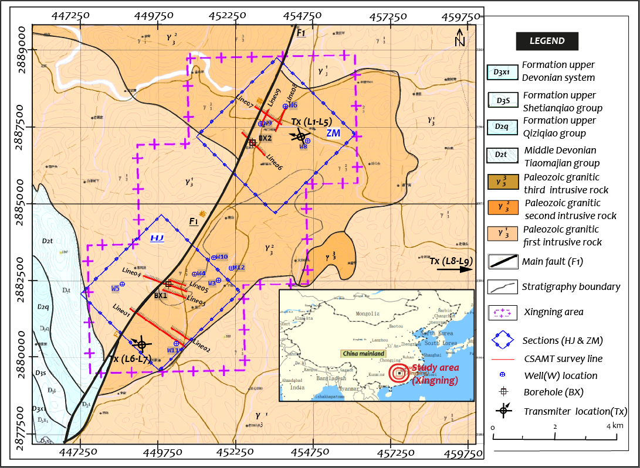

Figure 1:Simplified geological map of Xingning area and locations of CSAMT survey lines; HJS: Hejiashan section, ZMS: Zhoumensi section.

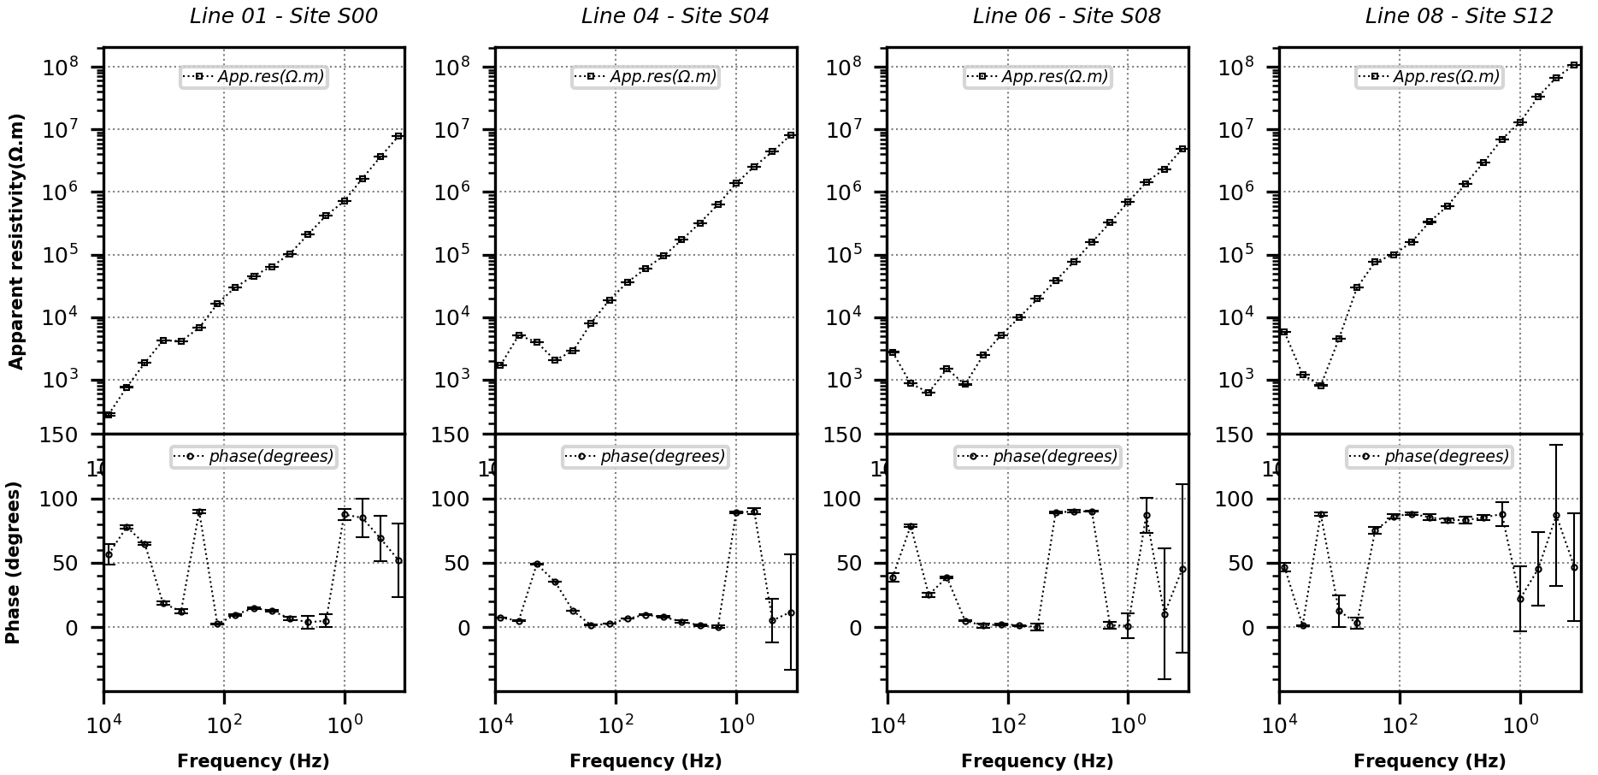

Figure 2: Typical apparent resistivity and phase curves of measured data at the sites S00, S04 , S08, S12 of line 01, line 04 , line 06 and line 08 respectively. The error bars (%) on the field data are small, generally less than 10% in resistivity while it is greater than 20% in phase especially from a frequency of 0.125 to 1 Hz.

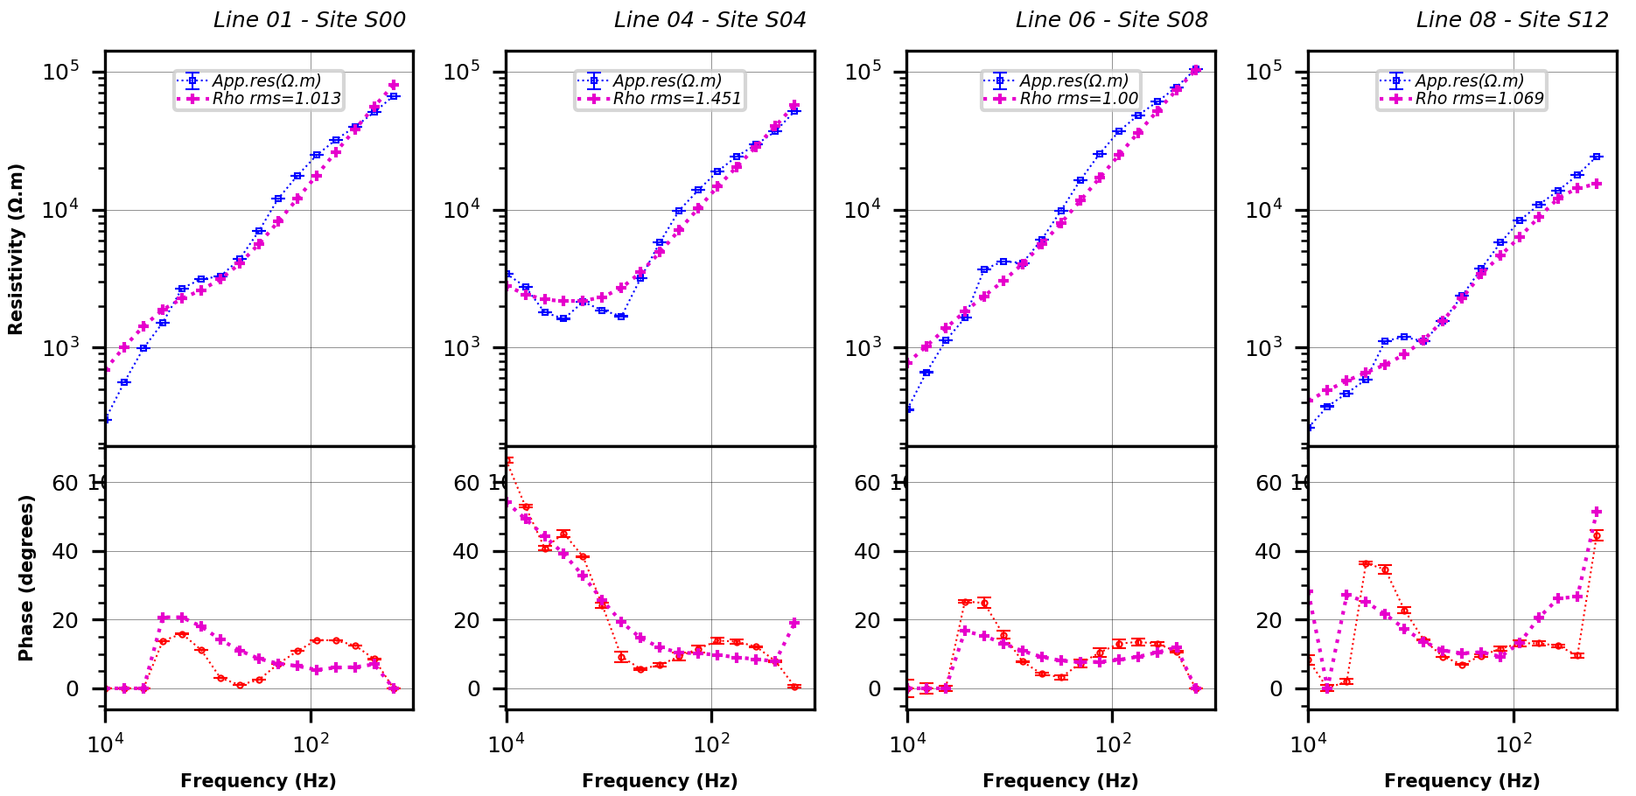

Figure 3: Some fitting curves of resistivity and phase inversion after applying on the CSAMT data the static shift correction. The error bars in % on the field CSAMT data are small, generally less than 5% in resistivity and 2° in phase. The purple dotlines is the forward modeling response using the algorithm of a FE structured grid (Wannamaker et al., 1987; DeGroot-Hedlin and Constable, 1990).

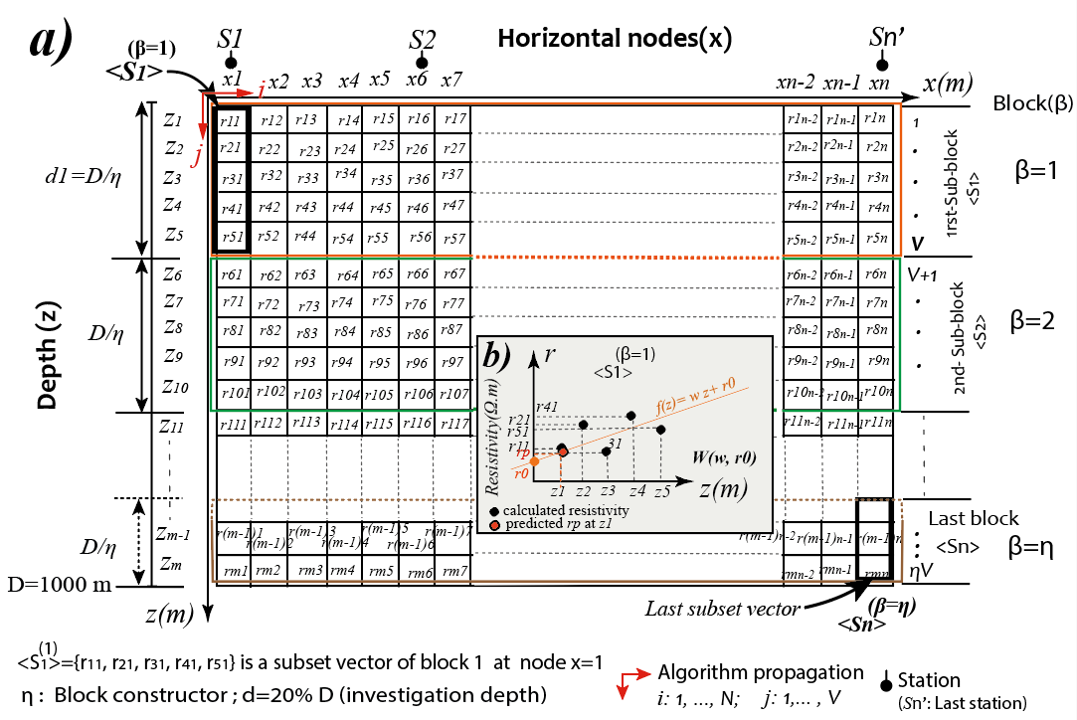

Figure 4: a) A simplified CRM FE structure grid to implement the different steps of the creation of the NM. Each cell Is a distinct conductivity. The forward computations require a finite element mesh with more nodes and cells than this and are not regular from near the surface and the edge and lower boundaries(Wannamaker et al., 1987; DeGroot-Hedlin and Constable, 1990). The algorithm propagates from the first station thin the last station on the x-axis and from the surface to the investigation depth (D) on the z-axis. b) An example of model function implementation. The error is computed between the predicted $r_{p}$ and the calculating resistivity $r_{v1}$ at each depth $v$.

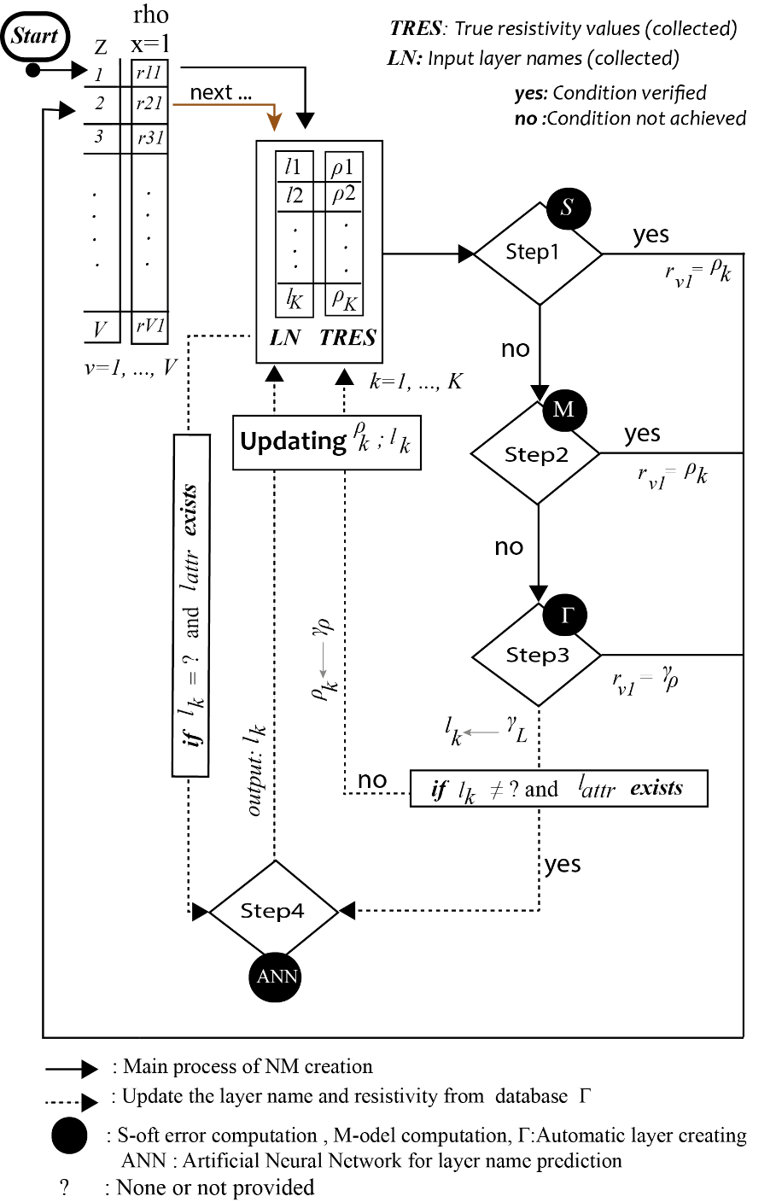

Figure 5: A simplified flow chart for the creation of the new model (NM). It is possible and recommended to predict the layer name when attributes are available and update the input layer name (LN) before creating the NM. $ρ_{k}$, $l_{k}$ are the real resistivity value and layer name at *k*-index in TRES and LN respectively. $r_{v1}$ is the calculated resistivity from TRES at depth *v* index 1 onthe *x-*axis. $γ_{L}$ and $γ_{ρ}$ are the automatic layer resistivity and name from database $Γ$. $l_{attr}$: layer $l_{k}$ additional properties.

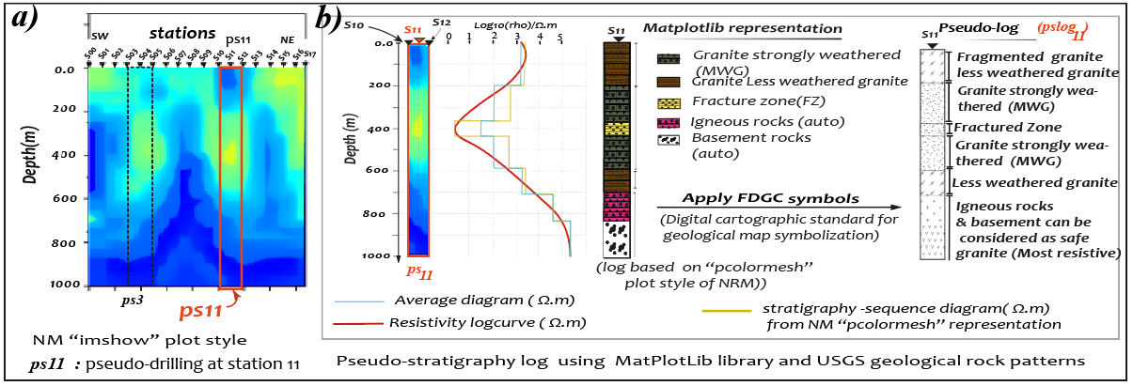

Figure 6: a) An example of the new model (NM) using MPL “*imshow*” plot style. The boundaries of the different layers in LN are well demarcated with their true resistivity values in TRES. The pseudo-drilling at station S11 is used to build the pseudo-stratigraphy log in b. b) The MPL representation of pseudo-stratigraphy log at station 11. Because the MPL library does not recognize the FGDC patterns, we apply for each layer its conventional geological FGDC symbols to get the “*pslog11”.*

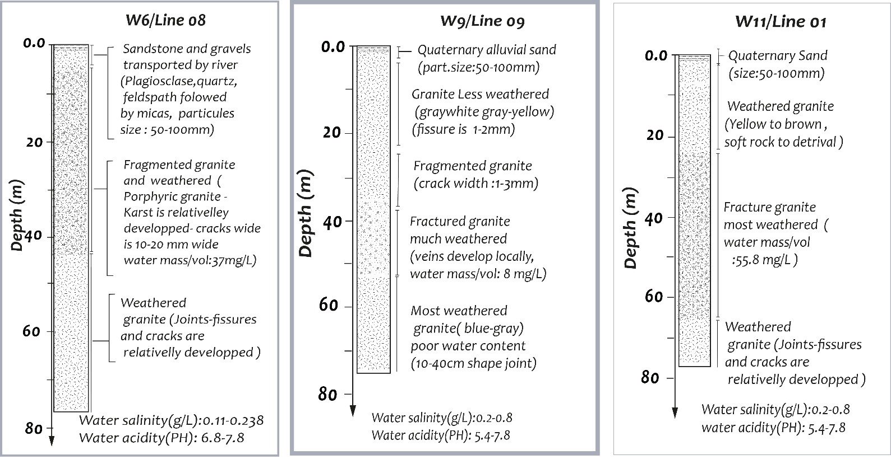

Figure 7: Well data collected on the Xingning area. Wells are not exactly located on survey lines and do notperfectly match any station locations. However, their close representation with the *survey* line is used to understand the layers’ superposition, especially at *the* first 100 m depth. Well *“W*6*”* is close to the last station of line 08 (S17) while well *“W*09*”* is located close to the first station *(S00)* of line 09 of the ZMS section. Well *“W*11*”* is closely located between station S42 and station S43of line 11 of the HJ section. The level of approximation of the well location to the survey line is expressed with the thickness of each frame.

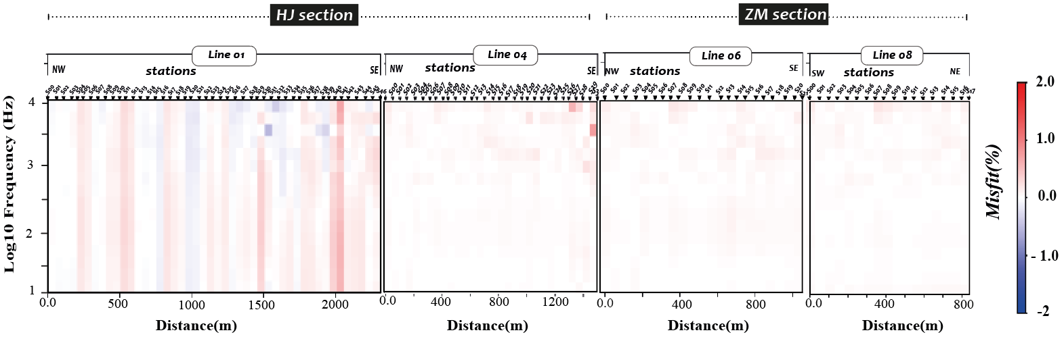

Figure 8: The model responses of the FE algorithms used. Thefit for the 04-representative line is 0.23% for line 01*, 0.18*% for line 04*,* 0.11% for line 06 and 0.09% for line 08*.* Overall, theforward solution responses for FE structured algorithms fit the ninesurvey lines with less than 1% misfit value

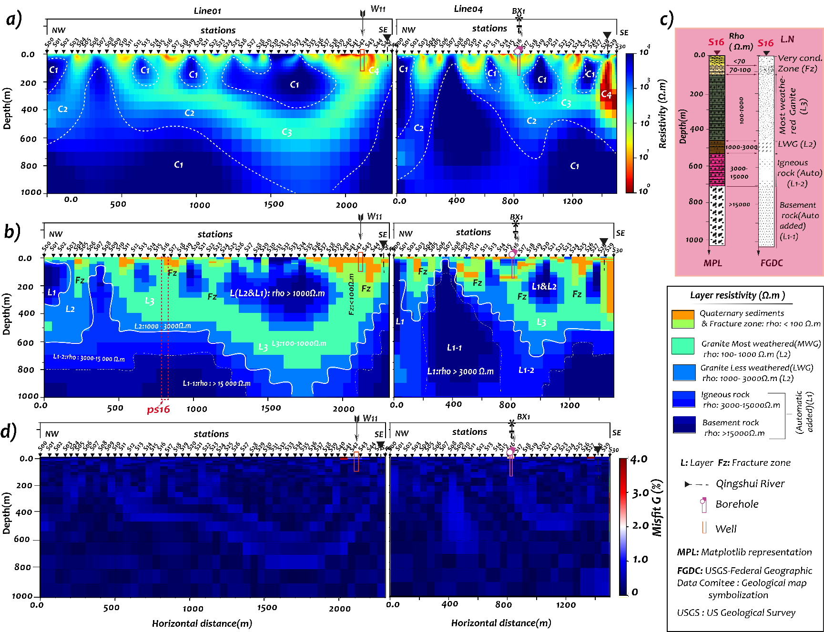

Figure 9: Line 01 and line 04 of the HJ section. a) CSAMT 2D inversion results with error floors set at 10% apparent resistivities and 20% phase for four representative lines with starting model set at 150 Ω.m; An approximated delimitation gives rho C1: >1000Ω.m, rho C2: 50-200 Ω.m, rho C3:200-1000 Ω.m, and rho C4: <50 Ω.m. The best delimitation can be obtained after applying the TRES into CRM. b) The NM model was generated using the details of Table 3. Five layers are demarcated. Because the max given resistivity on Table 3 is less than the max resistivity of the CRM, some additional layers were automatically created from the PT inner database and layers’ name recognition process. c) An example of pseudo-stratigraphy log construction at station 16 (S16) of line 04. d) NM misfit G t is obtained from the distribution of minimal errors location found during the creation of NM. Overall the NM misfit G is less than 1%.

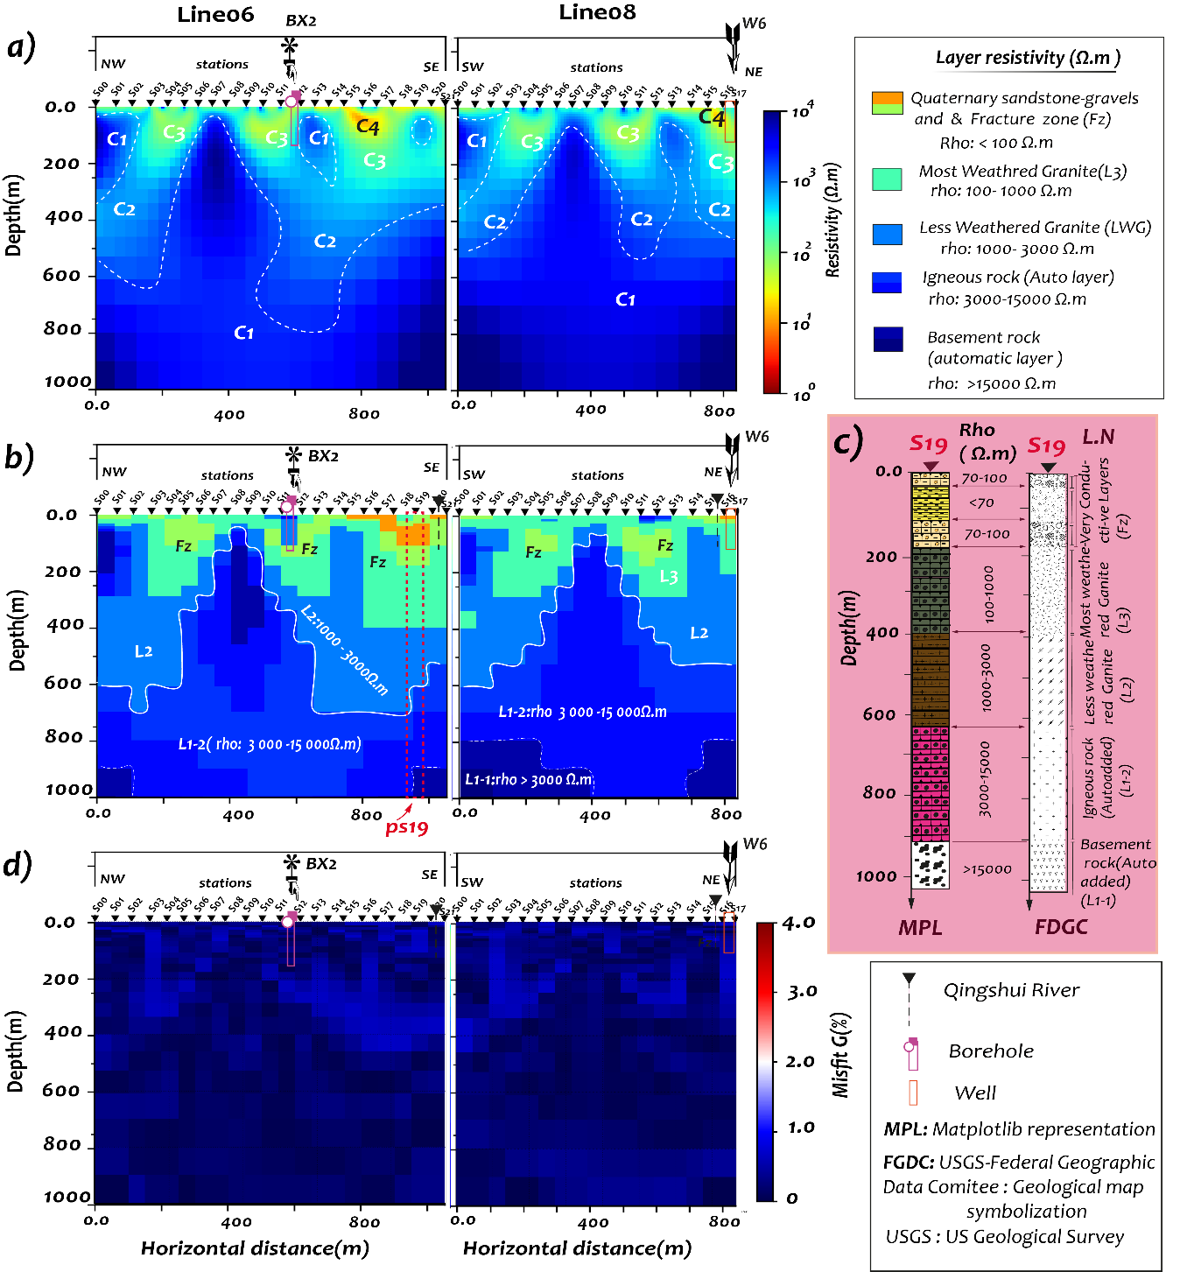

Figure 10: Line 06 and line 08 of the ZM section. a) CSAMT 2D Inversion results. b) The NM model generated using the input layers properties in Table 3. c) NM geo-misfit of two representative lines of the ZMS section. c) The pseudo-stratigraphy log was extracted at station 19 (S19) of line 06. d) The average NM misfit G from both lines is around 0.98%.

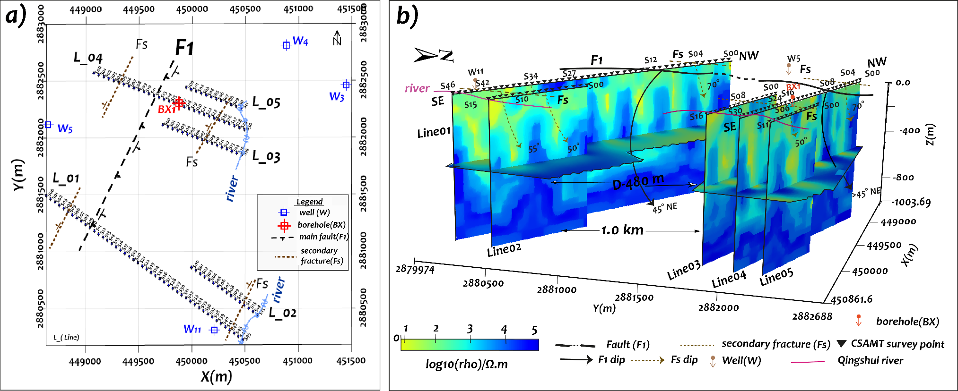

Figure 11: Surface map and combined section of HJS: The 3D routine does not allow the “*pcolormesh*” representation. Each section was represented using the “*imshow*” plot style for 3D view. a) Surface map; line 01 and line 02 are oriented at 126 $°$ while line 03 to line 05 are oriented at 110 $°$, b) Stacked sections map from CSAMT 2D inversion. The dip angle of the main fault (F1) is represented in perspective view.

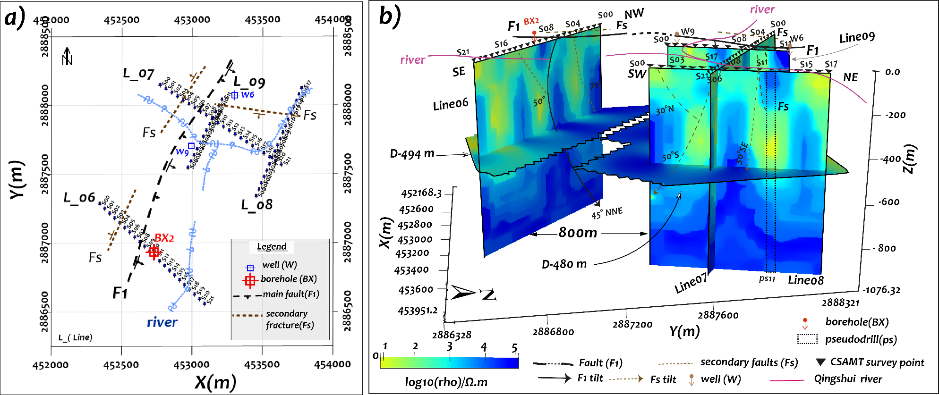

Figure 12: Surface map and combined sections of ZMS: a) Surface map; directions: line 06 is 135 $°$, line 07 is 130 $°$; line 08 and line 06 are 26 $°$ b) Stacked sections map from CSAMT 2D inversion. The dip angle of the main fault (F1) is represented in perspective view. *Ps11*: sample of the ‘pseudo-drill’ at station S11 of line 11 (see figure 5).

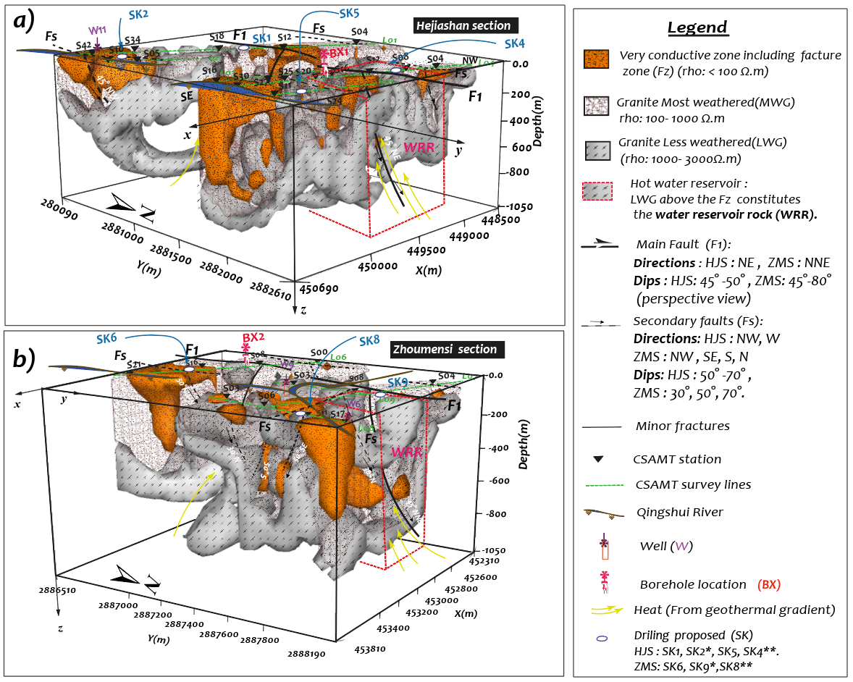

Figure 13: Three-dimensional pseudo-stratigraphy map. Fault F1 is represented on perspective view tilted 45 $°$ NE to 45 $°$ NNE. The secondary faults (Fs) tilted towards 50 $°$ NW, 70 $°$ NW, 30 $°$ N, 50 $°$ S and SE. The layer of less weathered granite (LWG) under the fracture zone constitutes the reservoir rock of the area with thickness estimated around 150 to 600 m. The strong weathered granite (MWG) are around 400-800 m thick. Located under a reservoir rock especially in the main fracture F1 zone, the MWG constitutes the main hot groundwater reservoir. a) HJ section b) ZM section

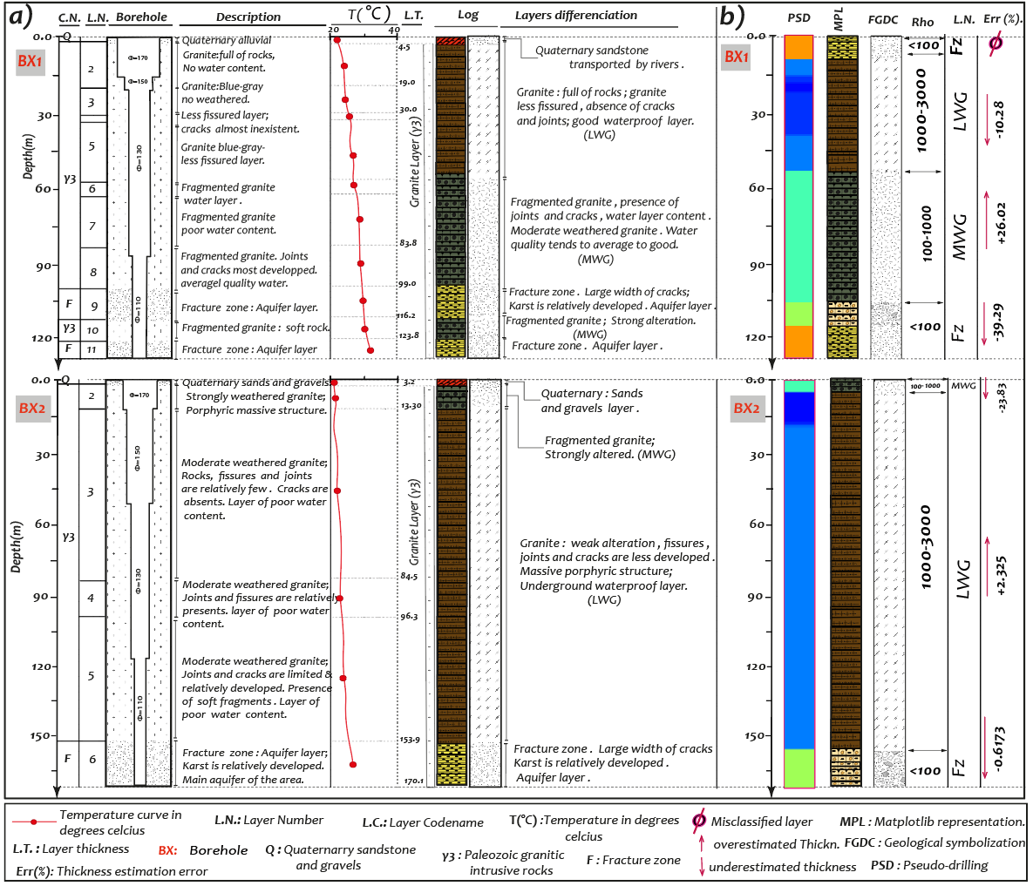

Figure 14: Boreholes BX1 and BX2 data of investigation area. The temperature of BX1 tends to increase to 31 $°C$ and shows more weathered granite due to acceleration of metamorphism . Contrary to BX1, BX2 displays the thickness of less weathered granite (LWG) around 144 m with water temperature around 22 $°C$. The thicker layer of LWG demonstrates the less intensity of geothermal activity in that place. Furthermore, the water flow obtained in BX2(4 l/s) is about 3.45 times higher than BX1 (1.16l/s). a) Layer differentiation according to borehole description. b) Boreholes log reconstruction based on NM. The logs in a) and b) are almost similar but the computation thickness shows the error between the handmaking description and the automatic pseudo-stratigraphy logs. Overall, the thickness layer is estimated at less than $±$ 40% especially between MWG and fracture zone.

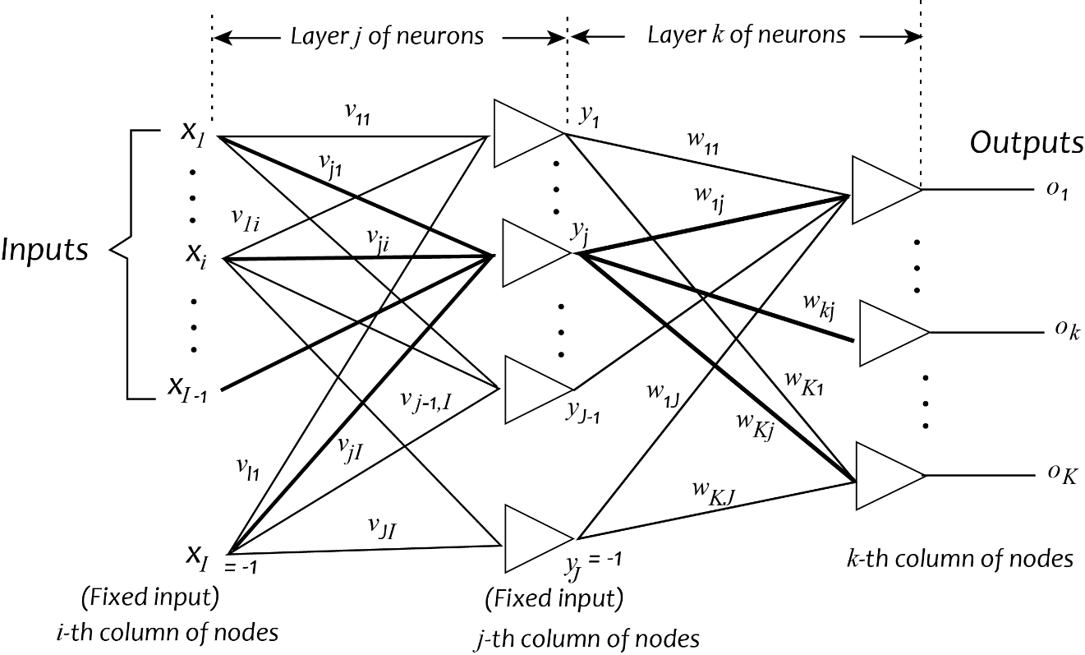

Figure 15: ANN scheme to predict a layer name from its attributes using the database $Γ$ properties. The bold arrow is used for theory explanation.

1. [FGDC Digital Cartographic Standard for Geologic Map Symbolization (PostScript Implementation) (usgs.gov)](https://pubs.usgs.gov/tm/2006/11A02/)
2. [www.zonge.com/legacy/PDF_DatPro/AmtAvg.pdf](http://www.zonge.com/legacy/PDF_DatPro/AmtAvg.pdf)
3. [astatic370s (zonge.com)](http://www.zonge.com/legacy/PDF_DatPro/Astatic.pdf)
4. [www.zonge.com/legacy/PDF_DatPro/AmtAvg.pdf](http://www.zonge.com/legacy/PDF_DatPro/AmtAvg.pdf)
5. [astatic370s (zonge.com)](http://www.zonge.com/legacy/PDF_DatPro/Astatic.pdf)
6. [FGDC Digital Cartographic Standard for Geologic Map Symbolization (PostScript Implementation) (usgs.gov)](https://pubs.usgs.gov/tm/2006/11A02/)
7. [OFR-03-420 - A Catalog of Porosity and Permeability from Core Plugs in Siliciclastic Rocks (usgs.gov)](https://pubs.usgs.gov/of/2003/ofr-03-420/ofr-03-420.html)